VIDENHANCE

– YOUTUBE OPTIMIZATION AND VISUALIZATION TOOL

*Project report submitted*

*For Review (Major Project) in fulfillment of*

*The requirement for the degree of*

**Bachelor of Technology**

**(Computer Science and Engineering)**

By

**Dhruv Patel – 20124004**

**Esha Gupta – 20124025**

**Rishita Srivastav – 20124026**

**Kosha Thakkar - 20124043**

**Guided By: Prof. Ujwala Petigara**



**Department of Computer Science and Engineering**

**School of Engineering and Technology**

**Navrachana University, Vadodara**

**May 2024**

**CERTIFICATE**

This is to certify that the project report entitled “VIDENHANCE – Youtube optimization and visualization tool” submitted by “Dhruv Patel, Esha Gupta, Rishita Srivastav and Kosha Thakkar” to School of Engineering and Technology (SET) of Navrachana University Vadodara, in partial fulfillment for the award of the degree of B. Tech in Computer Science and Engineering (CSE) department. This report is a bona fide record work that has been carried out under my supervision during academic year 2023-24. The contents of this report, in full or in parts, have not been submitted to any other Institution or University for the award of any degree or diploma.

|  |  |  |
| --- | --- | --- |
| **Prof. Ujwala Petigara**  Guide and Assistant Professor  Computer Science and Engineering  School of Engineering and Technology  Navrachana University, Vadodara  May 2024 | **Prof. Yogesh Chaudhari**  Program Chair and Assistant Professor  Computer Science and Engineering  School of Engineering and Technology  Navrachana University, Vadodara  May 2024 | **Dr. Ashish Jani**  Head and Professor  CSE, IT, BCA and BSc DS  School of Engineering and Technology  Navrachana University, Vadodara  May 2024 |

**Declaration**

I declare that this written submission represents my ideas in my own words and where others' ideas or words have been included, I have adequately cited and referenced the original sources. I also declare that I have adhered to all principles of academic honesty and integrity and have not misrepresented or fabricated or falsified any idea/data/fact/source in my submission. I understand that any violation of the above will be cause for disciplinary action by the Institute and can also evoke penal action from the sources which have thus not been properly cited or from whom proper permission has not been taken when needed.

|  |  |  |
| --- | --- | --- |
| **Name of the student** | **Student ID** | **Signature** |
| Dhruv Patel | 20124004 |  |
| Esha Gupta | 20124025 |  |
| Rishita Srivastav | 20124026 |  |
| Kosha Thakkar | 20124043 |  |

Date: 9/3/2024

**Acknowledgment**

Every project big or small is successful largely due to the effort of a number of wonderful people who have always given their valuable advice or lent a helping hand. We sincerely appreciate the inspiration, support and guidance of all those people who have been instrumental in making this project a success. We are extremely grateful to **Prof Ashish Jani**, (Head- CSE, IT BSc-DS, BCA) and **Prof Yogesh Chaudhari (**Program Chair- CSE) for entrusting our project “VIDENHANCE – Youtube optimization and visualization tool” and giving us the opportunity to undertake such kind of challenging and innovative work. We feel deeply honored in expressing our sincere thanks to our Internal Project Guide **Prof. Ujwala Petigara** for providing valuable insights leading to the successful completion of the project.

We would also like to thank all the faculty members of CSE for their critical advice and guidance without which this project would not have been possible.

Last but not the least we place a deep sense of gratitude to colleagues and friends who have been a constant source of inspiration during the preparation of this project work.

Dhruv Patel - 20124004

Esha Gupta - 20124025

Rishita Srivastav - 20124026

Kosha Thakkar - 20124043

# **LIST OF FIGURES**

|  |  |  |
| --- | --- | --- |
| **SR. NO.** | **TITLE** | **PAGE NO.** |
| Fig 1.1 | Comment analyzer | 22 |
| Fig 1.2 | Best titles | 23 |
| Fig 1.3 | Title Recommender | 24 |
| Fig 1.4 | Video transcript summerizer | 25 |
| Fig 1.5 | Real time analytics | 26 |
| Fig 1.6 | Channel monetization | 27 |
| Fig 1.7 | Channel ID extractor | 28 |
| Fig 1.8 | Post scheduler | 29 |
| Fig 2.1 | Architecture | 30 |
| Fig 2.2 | Architecture | 31 |
| Fig 3.1-3.33 | Result Screenshot | 34-53 |
| Fig 4.1 | Gantt Chart | 55 |

# **LIST OF TABLES**

|  |  |  |
| --- | --- | --- |
| **SR. NO.** | **TITLE** | **PAGE NO.** |
| Table 1.1 | Analytics database | 41 |
| Table 1.2 | Top 10 comments | 46 |
| Table 1.3 | Post scheduler | 49 |

# **ABSTRACT**

*In the rapidly evolving landscape of online content creation, the success of YouTube channels hinges on a deep understanding of audience preferences, effective optimization strategies, and data-driven decision-making. To address these critical needs, we introduce Videnhance, a comprehensive platform tailored specifically for YouTube content creators. Videnhance leverages cutting-edge AI technologies to empower creators with a diverse array of tools aimed at enhancing video performance, maximizing audience engagement, and fostering channel growth. At the core of Videnhance is a suite of features designed to provide invaluable insights and support throughout the content creation process. The Comment Analyzer Module offers real-time analysis of audience feedback, sentiment, and engagement patterns, enabling creators to better understand and respond to viewer preferences. Additionally, the Recommendations Engine harnesses AI algorithms to offer personalized suggestions for optimizing video titles, descriptions, and ideal posting times, thereby improving discoverability and audience reach. Videnhance further facilitates content optimization by curating lists of top-performing videos with similar titles, helping creators identify successful trends and topics for their own content. The Video Transcript Summarizer simplifies the process of condensing video content into concise summaries, enhancing accessibility and searchability for viewers. Real-time analytics functionality provides creators with immediate access to key performance metrics, empowering them to make informed decisions and adjustments to their content strategy as needed. In addition to these core features, Videnhance offers a range of supplementary tools and functionalities to support creators in their journey towards content excellence. These include a Keyword Generator for SEO optimization, and detailed statistics and top comments for individual videos. The platform's intuitive dashboard provides a user-friendly interface for accessing top-performing video insights, predictive analytics, and detailed performance metrics. By equipping creators with powerful AI-driven tools and actionable insights, Videnhance aims to revolutionize the way YouTube content is created, optimized, and shared. Whether you're a seasoned veteran or just starting out, Videnhance is your indispensable companion for unlocking the full potential of your YouTube channel and achieving sustainable growth in an increasingly competitive digital landscape.*

**Keywords:** content creation, audience engagement, optimization, data-driven, analytics, video performance, channel growth

**Table of Contents**

|  |  |  |
| --- | --- | --- |
|  | **Title** | **Page No**. |
|  | List of Figures | **I** |
|  | List of Tables | **II** |
|  | Abstract | **III** |
| 1 | Project Title, Scope and Definition | **1** |
| 2 | Motivation | **4** |
| 3 | Literature Review | **5** |
| 4 | System Requirements for its Development and Production Environment. | **16** |
| 5 | Stakeholders | **22** |
| 6 | Approach Used | **25** |
| 7 | Data/Corpus/Data Dictionary |  |
| 8 | Project/Data Flow Diagram / UML |  |
| 9 | Architecture Diagram |  |
| 10 | Prototype/Fully Developed Implementation’s Screenshot. |  |
| 11 | Results |  |
| 12 | Gantt Chart / Timeline |  |
| 13 | Proposed Enhancement |  |
| 14 | Conclusion |  |
| 15 | References |  |

**1.1 Project Title**

**1.1.1 Introduction to Videnhance**

Videnhance is a game-changing platform designed exclusively for YouTube creators, revolutionizing the landscape of online content creation. Through cutting-edge tools, Videnhance simplifies the process of optimizing videos, engaging audiences, and expanding channel reach.

With a user-friendly interface and intuitive features, Videnhance empowers creators to unlock their full potential and achieve unprecedented success in the competitive digital sphere.

At its core, Videnhance represents a paradigm shift in content creation, offering creators the tools they need to thrive in a dynamic online environment. By leveraging insights, creators can refine their content strategies, enhance viewer engagement, and maximize the impact of their videos.

Whether you're a seasoned creator or just starting out, Videnhance provides the resources and support necessary to elevate your content and stand out in a crowded marketplace.

With Videnhance, creators gain access to a comprehensive suite of features tailored to their specific needs and objectives. From analyzing audience feedback to optimizing video titles and descriptions, Videnhance streamlines every aspect of the content creation process, allowing creators to focus on what they do best – creating compelling and engaging content.

With Videnhance by their side, creators can confidently navigate the complexities of YouTube and unlock new opportunities for growth and success.

Creators gain access to a comprehensive platform designed to streamline their workflow and maximize their impact. From analyzing audience sentiment to generating optimized metadata, Videnhance offers a range of functionalities to meet the diverse needs of content creators.

Videnhance introduces a host of groundbreaking features tailored to meet the unique needs of YouTube creators, revolutionizing the content creation process. Through advanced AI algorithms, Videnhance offers creators the ability to analyze audience feedback, optimize video titles and descriptions, and identify the most opportune times for posting. Additionally, creators can leverage Videnhance's real-time analytics functionality to gain insights into video performance metrics, audience engagement trends, and emerging content niches, enabling them to make data-driven decisions and enhance their channel growth strategies.

Moreover, Videnhance offers intuitive tools such as the Comment Analyzer Module, which provides in-depth insights into audience sentiment and engagement patterns, and the Title Recommender, which suggests improvements for video metadata to enhance discoverability and viewer engagement.

With Videnhance's comprehensive suite of features, creators can streamline their workflow, maximize their reach, and unlock the full potential of their YouTube channels, empowering them to thrive in the competitive digital landscape.

Videnhance empowers creators to navigate the complexities of YouTube with confidence, helping them to build thriving channels and connect with audiences around the world.

With its intuitive interface, Videnhance simplifies the process of content optimization, audience analysis, and channel growth. From insightful analytics to personalized recommendations, Videnhance equips creators with the resources they need to succeed in the competitive digital landscape.

At the heart of Videnhance lies a commitment to empowering creators with actionable insights and practical tools to enhance their content strategy. Through features such as audience analysis, content optimization, and real-time analytics, Videnhance equips creators with the resources they need to make informed decisions and drive engagement. Whether it's refining video titles, curating content, or identifying emerging trends, Videnhance provides creators with the tools and support to unleash their creativity and captivate their audience.

**1.2 Scope**

The scope of the Videnhance project encompasses the development and implementation of a comprehensive platform tailored specifically for YouTube content creators. The primary objective is to provide creators with a suite of AI-driven tools and functionalities to enhance their content, engage their audience, and foster channel growth. The project will include the following key components:

**1.2.1 Feature Development:**

Development of AI-powered tools such as Comment Analyzer Module, Recommendations Engine, Title Recommender, Description Generator, and Keyword Generator.

Implementation of real-time analytics functionality to provide creators with instant access to key performance metrics.

Integration of features for content optimization, audience analysis, and trend identification.

**1.2.2 User Interface Design:**

Design and development of a user-friendly interface for easy navigation and interaction with Videnhance's features.

Creation of intuitive dashboards to visualize performance metrics, top-performing videos, and audience engagement trends.

Implementation of responsive design principles to ensure compatibility.

**1.2.3 Testing and Quality Assurance:**

Conducting comprehensive testing to ensure the stability, performance, and security of the Videnhance platform.

Iterative testing and feedback collection to refine features and improve user experience based on user input.

Implementation of rigorous quality assurance protocols to identify and address any bugs or issues before deployment.

**1.2.4 Enhanced Visualization:**

Integration of a download option in every section of the platform to enable creators to export data, analytics, and visualizations for further analysis or presentation purposes.

Creators can download reports, charts, and insights generated by Videnhance, allowing them to delve deeper into their data and share findings with collaborators or stakeholders.

This feature enhances the usability of Videnhance by providing creators with the flexibility to access and utilize their data offline or in other applications as needed.

The download option contributes to a more seamless and efficient workflow, empowering creators to make informed decisions and take actionable steps towards optimizing their content and channel performance.

**1.2.5 Deployment and Launch:**

Deployment of the Videnhance platform on scalable infrastructure to support growing user demand.

Launch of the platform with a targeted marketing campaign to attract YouTube content creators and promote adoption.

Ongoing monitoring and optimization to ensure the smooth operation and continued improvement of the Videnhance platform post-launch.

**1.3 Definition**

Content creators on YouTube often grapple with complexities surrounding audience sentiment analysis, content optimization, and understanding video performance metrics. These challenges hinder their ability to maximize channel growth and reach wider audiences.

Videnhance emerges as a comprehensive solution, leveraging advanced AI technologies to provide creators with intuitive tools and insights. By offering features such as the Comment Analyzer Module, Recommendations Engine, and real-time analytics, Videnhance aims to empower creators to optimize their content, engage their audience effectively, and propel their channels towards sustained success in the competitive digital ecosystem.

The scope of the Videnhance project encompasses the development of a user-centric platform specifically tailored to the needs of YouTube content creators. Through a combination of intuitive user interface design, robust backend infrastructure, and rigorous testing protocols, Videnhance will deliver a seamless and efficient user experience. Moreover, the inclusion of a download option in every section of the platform enhances data visualization and usability, providing creators with flexibility in accessing and utilizing their insights for further analysis or presentation purposes.

Ultimately, the outcome of the Videnhance project is a transformative platform that empowers YouTube content creators to overcome challenges related to audience sentiment analysis, content optimization, and video performance insights.

By equipping creators with actionable insights and practical tools, Videnhance aims to foster channel growth, enhance discoverability, and facilitate meaningful engagement with audiences, positioning creators for sustained success in the dynamic and competitive landscape of online content creation.

**2. Motivation**

The motivation behind the development of Videnhance stems from a deep-seated recognition of the challenges faced by YouTube content creators in navigating the intricacies of audience engagement, content optimization, and channel growth.

With the exponential growth of online content consumption and the increasing competitiveness of the digital landscape, it has become imperative for creators to have access to advanced tools and insights to stay ahead of the curve.

Videnhance is motivated by the desire to empower content creators with the resources they need to thrive in this dynamic environment. By harnessing the power of AI-driven technologies, Videnhance seeks to democratize access to sophisticated analytics and optimization tools that were once exclusive to large-scale enterprises.

This democratization of technology not only levels the playing field for creators of all backgrounds but also fosters a culture of innovation and creativity within the YouTube community.

Furthermore, the motivation behind Videnhance lies in the belief that every creator deserves the opportunity to realize their full potential and achieve their goals. Whether it's reaching a wider audience, monetizing their content, or making a meaningful impact, Videnhance aims to provide creators with the support and guidance they need to turn their passion into success.

By equipping creators with actionable insights, intuitive tools, and a supportive community, Videnhance strives to be the catalyst for transformative growth and empowerment in the world of online content creation.

Videnhance is driven by the understanding that effective content creation goes beyond mere production it requires a deep understanding of audience preferences, trends, and analytics. With this in mind, Videnhance aims to bridge the gap between creators and their audience by providing valuable insights into audience sentiment and engagement patterns.

Videnhance is motivated by the potential for innovation and growth inherent in the digital content creation space. As technology continues to evolve and new platforms emerge, there is an ever-increasing demand for innovative solutions that can adapt to changing trends and user behaviors. By constantly pushing the boundaries of what's possible and staying ahead of the curve in terms of technological advancements, Videnhance aspires to be at the forefront of this innovation, driving positive change and empowering creators to realize their visions in ways previously thought impossible.

**3. Literature Review**

1. **Twitter Sentiment Analysis:**
   1. Objectives: Development of a sentiment analysis algorithm for Twitter messages, with a focus on challenges specific to Twitter data.
   2. Tools Used: Machine learning classifiers (Naive Bayes, MaxEnt, SVM), feature extractors, Twitter API.
   3. Methodology: Training data collection from Twitter, manual labeling, exploration of classifiers and feature selection.
   4. Conclusions: Achieved 85% accuracy in sentiment classification, highlighted challenges of handling neutral tweets and semantics.
2. **RoBERTa-LSTM:**
   1. Objectives: Develop a sentiment analysis hybrid model using RoBERTa and LSTM, addressing imbalanced datasets.
   2. Tools Used: RoBERTa, LSTM, GloVe, various machine learning models.
   3. Methodology: Data preprocessing, data augmentation, hybrid model implementation, hyperparameter tuning, performance evaluation.
   4. Conclusions: Outperformed state-of-the-art methods, emphasized effectiveness of RoBERTa-LSTM hybrid model.
3. **Text Summarizer Using NLP:**
   1. **Objectives:** Develop a text summarization system using NLP, specifically TF-IDF extractive summarization.
   2. Tools Used: NLTK, TF-IDF algorithm.
   3. Methodology: Data preprocessing, TF-IDF calculation, sentence scoring, summary generation.
   4. Conclusions: Effective TF-IDF-based extractive summarization, limitations in handling illogical or repetitive text.
4. **Analysis Using Product Review Data:**
   1. Objectives: Address sentiment analysis challenges using online product reviews from Amazon.com.
   2. Tools Used: scikit-learn, Naïve Bayesian, Random Forest, SVM.
   3. Methodology: Collection of product reviews, sentiment token analysis, POS tagging.
   4. Conclusions: Averaged sentiment scores, sentiment tokens as strong features, challenges in review-level categorization.
5. **Video Search Engine Optimization:**
   1. Objectives: Optimize video ranking on YouTube through keyword and feature analysis.
   2. Features: YouTube as primary platform, keyword tags, query log analysis, experimentation with ten videos.
   3. Conclusions: Keyword selection impact on rankings, consideration of features like shares and comments.
6. **Extractive Text Summarization:**
   1. Objectives: Implement an extractive text summarization system.
   2. Tools Used: Beautiful Soup, regular expressions, scikit-learn, genism.
   3. Methodology: Web scraping, preprocessing, feature extraction, LSA/LDA models, performance evaluation.
   4. Conclusions: LSA performed better than LDA, challenges in improving ROUGE-N recall scores.
7. **Advanced NLP Applications with OpenAI:**
   1. Objectives: Explore text summarization using OpenAI's GPT-3 API.
   2. Tools Used: OpenAI's GPT-3 API, Python.
   3. Methodology: Setup of OpenAI API credentials, text preprocessing, GPT-3 API usage, evaluation.
   4. Conclusions: GPT-3 API effectiveness in text summarization, considerations for creativity and coherence.
8. **ML-Enabled Models for YouTube Ranking:**
   1. Objectives: Identify and estimate YouTube video reach and views using ML techniques.
   2. Tools Used: Web-based interactive tool, IBM Watson.
   3. Methodology: Data gathering, exploratory data analysis, dataset preparation, model training, API integration, ranking mechanism.
   4. Conclusions: Proposed model for predicting views, ranking mechanism based on trending topics.

**9. Text Summarization:**

1. Objectives: Identify and analyze research topics/trends in text summarization. Provide an overview of various approaches to text summarization and classify them
2. Tools used: The SLR methodology employed a targeted search strategy using specific keywords and synonyms, followed by study selection based on predefined criteria, with research questions formulated using PICOC criteria.
3. Methodology: The SLR(Systematic Literature Review) method was chosen for its scientific rigor and systematic approach, allowing for clear and accountable results.
4. Conclusion: The review covers various aspects of text summarization, including datasets, preprocessing, features, approach techniques, problems, methods, and evaluations. It also highlights the use of different technologies such as fuzzy logic, deep learning algorithms,

and ensemble learning to enhance text summarization.

**10. Summary and keyword extraction:**

1. Objectives: Proposing methods for summarizing YouTube videos and extracting keywords, with a user-friendly interface, to enhance information extraction efficiency.
2. Tools used: Utilizing Python libraries like youtube_transcript_api and punctuator, alongside methods like TF-IDF, with Flask for API and React for UI, to automate YouTube video summarization and keyword extraction.
3. Methodology: The review examines extractive and abstractive methods for YouTube video summarization, including TextRank algorithm for sentence ranking and summarization.
4. Conclusion: The project aims to offer both extractive and abstractive methods for YouTube video summarization, prioritizing user-friendly interface and efficiency in information extraction.

**4. System Requirements for its Development and Production Environment.**

**4.1 System Requirements for Development Environment:**

1. **Operating System:**

Videnhance should be compatible with major operating systems such as Windows, macOS, and Linux to accommodate developers using different environments.

1. **Development Tools:**

Integrated Development Environment (IDE) such as Visual Studio Code, PyCharm, or Eclipse for coding, debugging, and version control.

1. **Programming Languages:**

Proficiency in programming languages such as Python, JavaScript, HTML/CSS, and SQL for backend, frontend, and database development.

1. **Frameworks and Libraries:**

Utilization of frameworks and libraries such as Flask for backend development, and TensorFlow or PyTorch for AI functionalities.

1. **Database Management System:**

Integration with a database management system like MySQL for data storage and retrieval.

1. **AI and Machine Learning Tools:**

Access to AI and machine learning libraries and tools such as TensorFlow, Keras, or scikit-learn for implementing AI-driven features.

1. **Collaboration Tools:**

Adoption of collaboration tools like Git for version control, GitHub or Bitbucket for code repository management, and Slack or Microsoft Teams for communication among development team members.

1. **Testing Frameworks**:

Integration with testing frameworks such as pytest, Selenium, for automated testing of codebase functionalities.

1. **Deployment Environment:**

Capability to deploy and test the application on local servers or cloud platforms such as Streamlit.

**4.2 System Requirements for Production Environment:**

1. **Operating System:**

Compatibility with server operating systems like Linux distributions (e.g., Ubuntu, CentOS) for hosting the application.

1. **Web Server:**

Installation of a web server such as Apache or Nginx to serve web pages and handle HTTP requests..

1. **Database System:**

Deployment of a robust and scalable database management system (e.g., MySQL, PostgreSQL) to store and manage application data.

1. **Security Measures:**

Integration with a database management system like MySQL, or MongoDB for data storage and retrieval.

1. **AI and Machine Learning Tools:**

Implementation of security measures such as SSL certificates, firewalls, and secure authentication protocols to protect user data and prevent unauthorized access..

1. **Scalability:**

Provisioning of scalable infrastructure and resources to accommodate increasing user traffic and data volume over time.

1. **Monitoring and Logging**:

Integration with monitoring tools like Prometheus or ELK stack for monitoring system performance, identifying issues, and generating logs for debugging and troubleshooting.

1. **High Availability:**

Configuration of load balancers, redundancy measures, and failover mechanisms to ensure high availability and minimize downtime.

**5. Stakeholders**

As the project initiator and developer, we the university students are integral stakeholders in the Videnhance project. Taking on multiple roles including project management, development, and decision-making, they are directly responsible for the conceptualization, execution, and success of Videnhance. Their academic pursuits, learning objectives, and personal growth are intertwined with the project's progress and outcomes. Additionally, as representatives of the university community, they may seek guidance and support from academic advisors or mentors within the university ecosystem to ensure alignment with academic standards and best practices.

However on a larger scale the potential stakeholder could be:

1. **Content Creators:**

The primary stakeholders of the Videnhance project are YouTube content creators who will utilize the platform to optimize their videos, analyze audience feedback, and enhance their channel's performance. Their input and feedback are crucial for shaping the features and functionalities of Videnhance to meet their specific needs and preferences.

1. **Development Team:**

The development team responsible for designing, building, and maintaining the Videnhance platform are key stakeholders. This includes software engineers, data scientists, UI/UX designers, and project managers who collaborate to ensure the successful development and deployment of Videnhance. Their expertise and contributions drive the implementation of features and functionalities according to project requirements.

1. **End Users:**

End users, including viewers of YouTube content, are stakeholders indirectly impacted by Videnhance. The platform aims to improve the quality and relevance of YouTube content, thereby enhancing the viewing experience for end users. Their feedback and interaction with the platform may influence future updates and enhancements.

1. **Management Team:**

The management team within the organization overseeing the Videnhance project are stakeholders responsible for setting project goals, allocating resources, and ensuring alignment with overall business objectives. Their support and guidance are essential for driving the project forward, securing necessary approvals, and managing project timelines and budgets.

1. **Investors and Financial Stakeholders:**

Investors and financial stakeholders who have invested in the development of Videnhance are stakeholders with a vested interest in the project's success. Their financial support and expectations for return on investment (ROI) influence strategic decisions and project priorities.

1. **Regulatory Bodies and Compliance Officers:**

Regulatory bodies and compliance officers responsible for ensuring adherence to legal and regulatory requirements, such as data privacy laws (e.g., GDPR), are stakeholders involved in overseeing compliance aspects related to the collection, storage, and processing of user data within Videnhance.

1. **Partners and Collaborators:**

Partnerships and collaborations with other organizations or platforms, such as YouTube or AI technology providers, are stakeholders who may contribute resources, expertise, or integration capabilities to enhance the functionality and reach of Videnhance.

1. **Marketing and Sales Teams:**

Marketing and sales teams responsible for promoting and selling Videnhance to potential users are stakeholders involved in driving user adoption and generating revenue. Their efforts in market research, customer acquisition, and retention strategies impact the platform's success in the marketplace.

**6. Approach Used**

The approach adopted for the development of Videnhance involves a structured and iterative process, designed to ensure efficient project management, collaboration, and timely delivery of high-quality outcomes. As university students leading the project, the approach encompasses the following key components:

1. **Requirement Analysis:**

Thorough requirement analysis is conducted to understand the needs and pain points of YouTube content creators. This involves gathering input from potential users through surveys, interviews, and market research.Requirements are documented, prioritized, and validated to ensure alignment with the project's objectives and stakeholders' expectations. This includes defining user stories, feature sets, and acceptance criteria.

1. **Agile Methodology:**

The Agile methodology is adopted to facilitate iterative development and flexibility in responding to changing requirements. Development cycles, known as sprints, typically last two to four weeks and result in incremental releases of functionality.Scrum frameworks may be utilized to organize tasks, track progress, and hold regular sprint planning, review, and retrospective meetings. This allows for transparency, accountability, and continuous improvement throughout the development process.

1. **Prototyping and MVP Development:**

Rapid prototyping techniques, such as wireframing and mockups, are employed to visualize and validate initial designs and concepts. This helps in eliciting early feedback from stakeholders and refining the user experience.A Minimum Viable Product (MVP) approach is adopted to prioritize essential features and deliver a basic, functional version of Videnhance to users for testing and validation. This allows for early market validation and iterative refinement based on user feedback.

1. **Collaborative Development:**

Collaboration among team members is facilitated through regular communication channels, such as Slack, Microsoft Teams, or Discord, as well as collaboration tools like Google Workspace, Trello, or Asana.Tasks are assigned based on individual expertise and priorities, with team members encouraged to collaborate, share knowledge, and assist each other as needed. Regular stand-up meetings or check-ins help ensure alignment and address any blockers or issues.

1. **Continuous Testing and Feedback:**

Continuous testing is integrated into the development process, with automated testing frameworks utilized for unit tests, integration tests, and end-to-end testing. User testing sessions are conducted regularly to gather feedback on new features, usability, and overall user experience. Feedback is analyzed, prioritized, and incorporated into subsequent development iterations to iteratively improve Videnhance.

.

1. **Incremental Deployment and Iterative Improvement:**

Videnhance is deployed incrementally, with new features and updates released iteratively based on the Agile development roadmap and user feedback. Continuous integration/continuous deployment (CI/CD) pipelines are set up to automate the build, testing, and deployment processes, ensuring rapid and reliable releases with minimal downtime.

1. **Documentation and Knowledge Sharing:**

Comprehensive documentation is maintained throughout the development process, including requirements specifications, design documents, technical guides, and user manuals. Knowledge sharing sessions, code reviews, and pair programming activities are conducted within the team to foster collaboration, cross-functional learning, and adherence to coding standards and best practices.

By following this detailed approach, university students leading the Videnhance project aim to deliver a high-quality, user-centric platform that meets the needs of YouTube content creators while also enhancing their own skills and knowledge in software development and project management.

**7. Data Dictionary**

1. **YouTube Video Data:**
   1. Video ID**:** Unique identifier for each YouTube video.
   2. Title: Title of the video.
   3. Description: Description provided for the video.
   4. Views: Number of views the video has received.
   5. Likes: Number of likes the video has received.
   6. Dislikes: Number of dislikes the video has received.
   7. Comments: Number of comments posted on the video.
   8. Tags: Tags associated with the video for categorization.
2. **YouTube Comment Data:**
   1. Comment ID: Unique identifier for each comment.
   2. Video ID: Identifier linking the comment to the respective YouTube vid
   3. Author: Username or display name of the commenter.
   4. Comment Text: Text content of the comment.
   5. Timestamp: Date and time when the comment was posted.
   6. Likes: Number of likes the comment has received.
   7. Replies: Number of replies to the comment.
3. **YouTube Channel Data:**
   1. Channel ID: Unique identifier for each YouTube channel.
   2. Channel Name: Name of the YouTube channel.
   3. Description: Description provided for the channel.
   4. Subscribers: Number of subscribers to the channel.
   5. Total Videos: Total number of videos uploaded to the channel.
   6. Channel Creation Date: Date when the channel was created.
4. **OpenAI API Data (Title Recommender and Summary Generator):**
   1. Input Text: Text data provided to the OpenAI API for processing (e.g.,

video title, video transcript).

* 1. Output Text: Text generated by the OpenAI API in response to the input

text (e.g., recommended video title, summarized content).

1. **Scheduler Data:**
   1. Video ID: Unique identifier for each scheduled video.
   2. Scheduled Date and Time: Date and time when the video is scheduled
   3. Status: Status of the scheduled video (e.g., pending, posted).
2. **Channel ID Data:**
   1. Channel ID: Unique identifier for each YouTube channel.
   2. Channel Name: Name of the YouTube channel.
   3. Creator: Username or display name of the channel creator.
3. **Monetization Check Data:**
   1. Channel ID: Unique identifier for each YouTube channel.
   2. Monetization Status: Status indicating whether the channel is eligible for

monetization (e.g., eligible, ineligible).

* 1. Revenue: Estimated revenue generated by the channel (if applicable).

The key data entities and attributes relevant to the Videnhance project, encompassing YouTube video, comment, and channel data, as well as data processed through the OpenAI API, scheduler, channel ID generation, and monetization check functionalities.

The data dictionary provided offers a comprehensive overview of the essential data entities and attributes central to the Videnhance project. It encompasses various facets of YouTube content, including video metadata such as titles, descriptions, views, likes, and comments. Additionally, it incorporates data pertaining to YouTube channels, including channel IDs, names, subscriber counts, and creation dates. This wealth of information not only forms the foundation for Videnhance's functionality but also serves as the primary source for analysis and optimization strategies aimed at enhancing content creators' visibility and engagement on the platform.

Moreover, the data dictionary extends its coverage to include insights derived from external APIs, notably the OpenAI API. This integration allows Videnhance to generate optimized video titles and summaries, leveraging advanced AI capabilities to enhance content discoverability and relevance. Furthermore, the scheduler, channel ID generation, and monetization check functionalities contribute to the project's holistic approach by facilitating efficient content management, channel identification, and revenue assessment, respectively. By encompassing a diverse array of data entities and attributes, the data dictionary underscores the project's multifaceted nature and its commitment to providing content creators with a comprehensive suite of tools to thrive on the YouTube platform.

**8. Data Flow Diagrams**

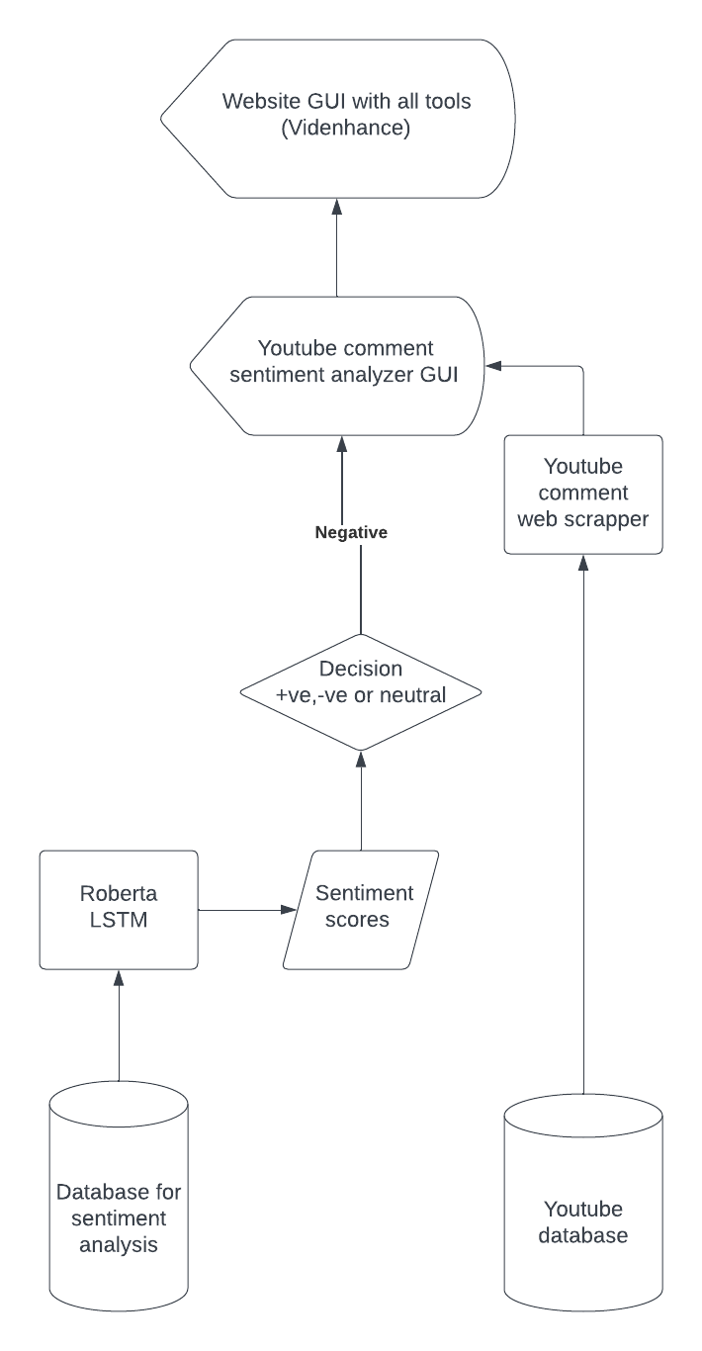

Fig 1.1

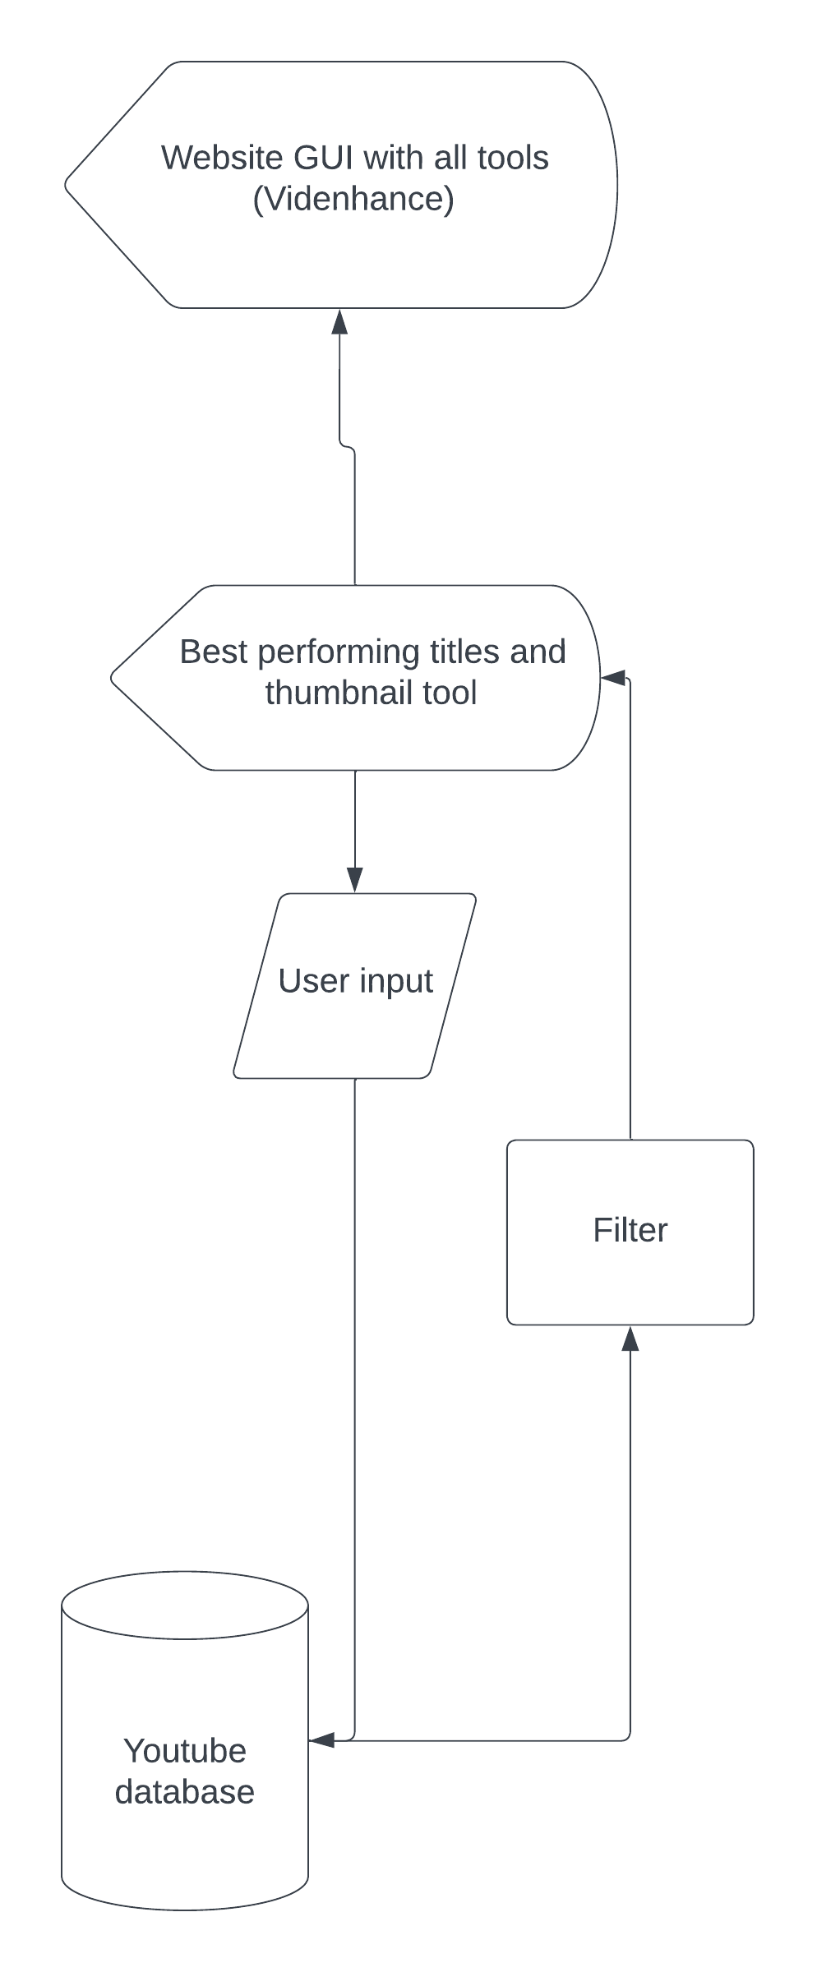

Fig 1.2

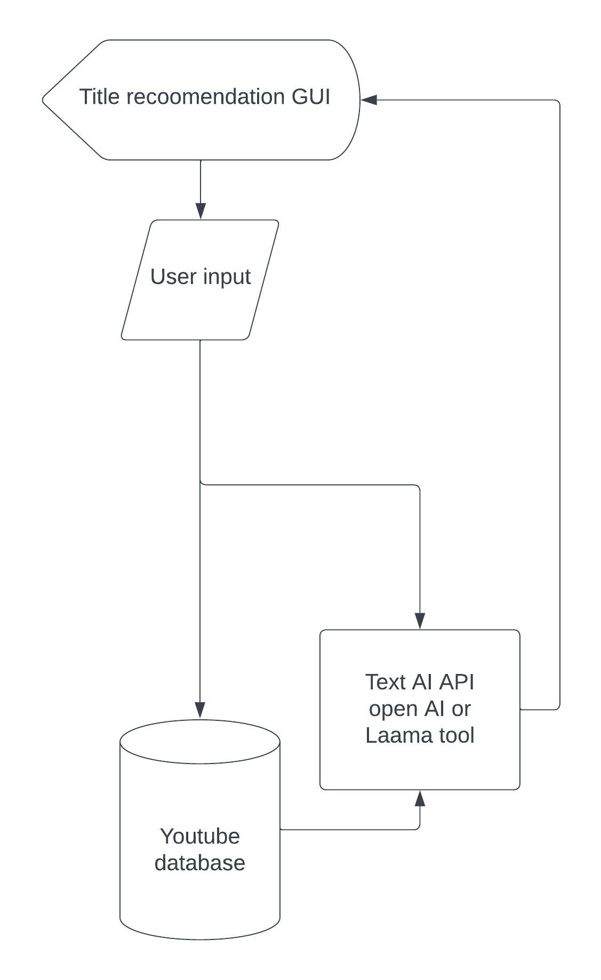

Fig 1.3

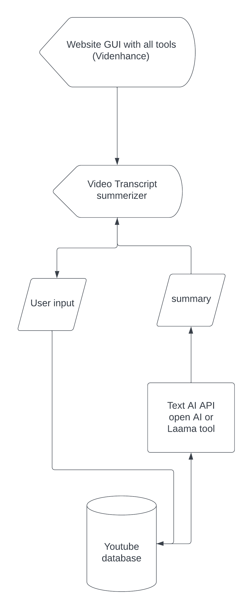

Fig 1.4

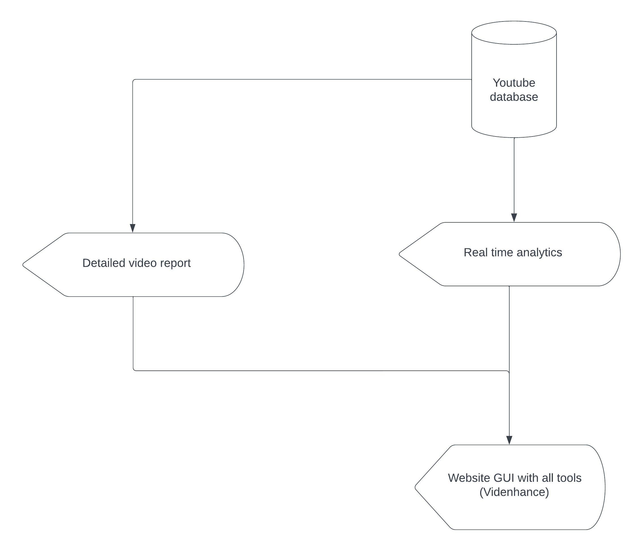

Fig 1.5

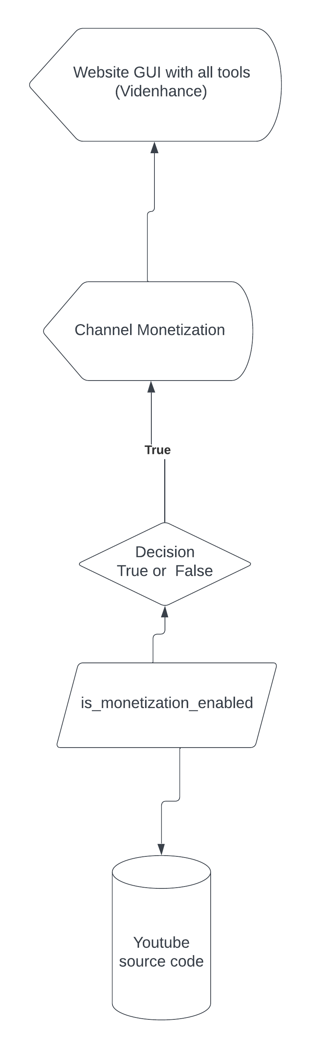

Fig 1.6

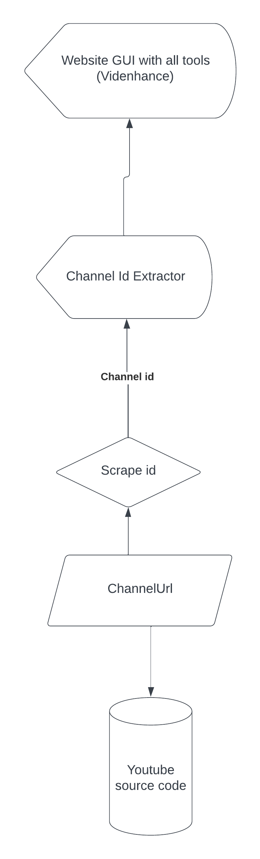

Fig 1.7

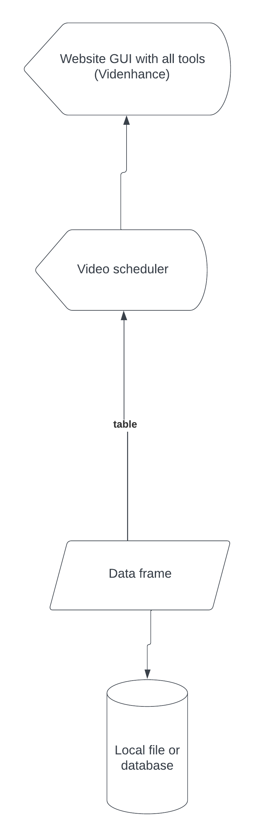

Fig 1.8

**9. Architecture Diagram**

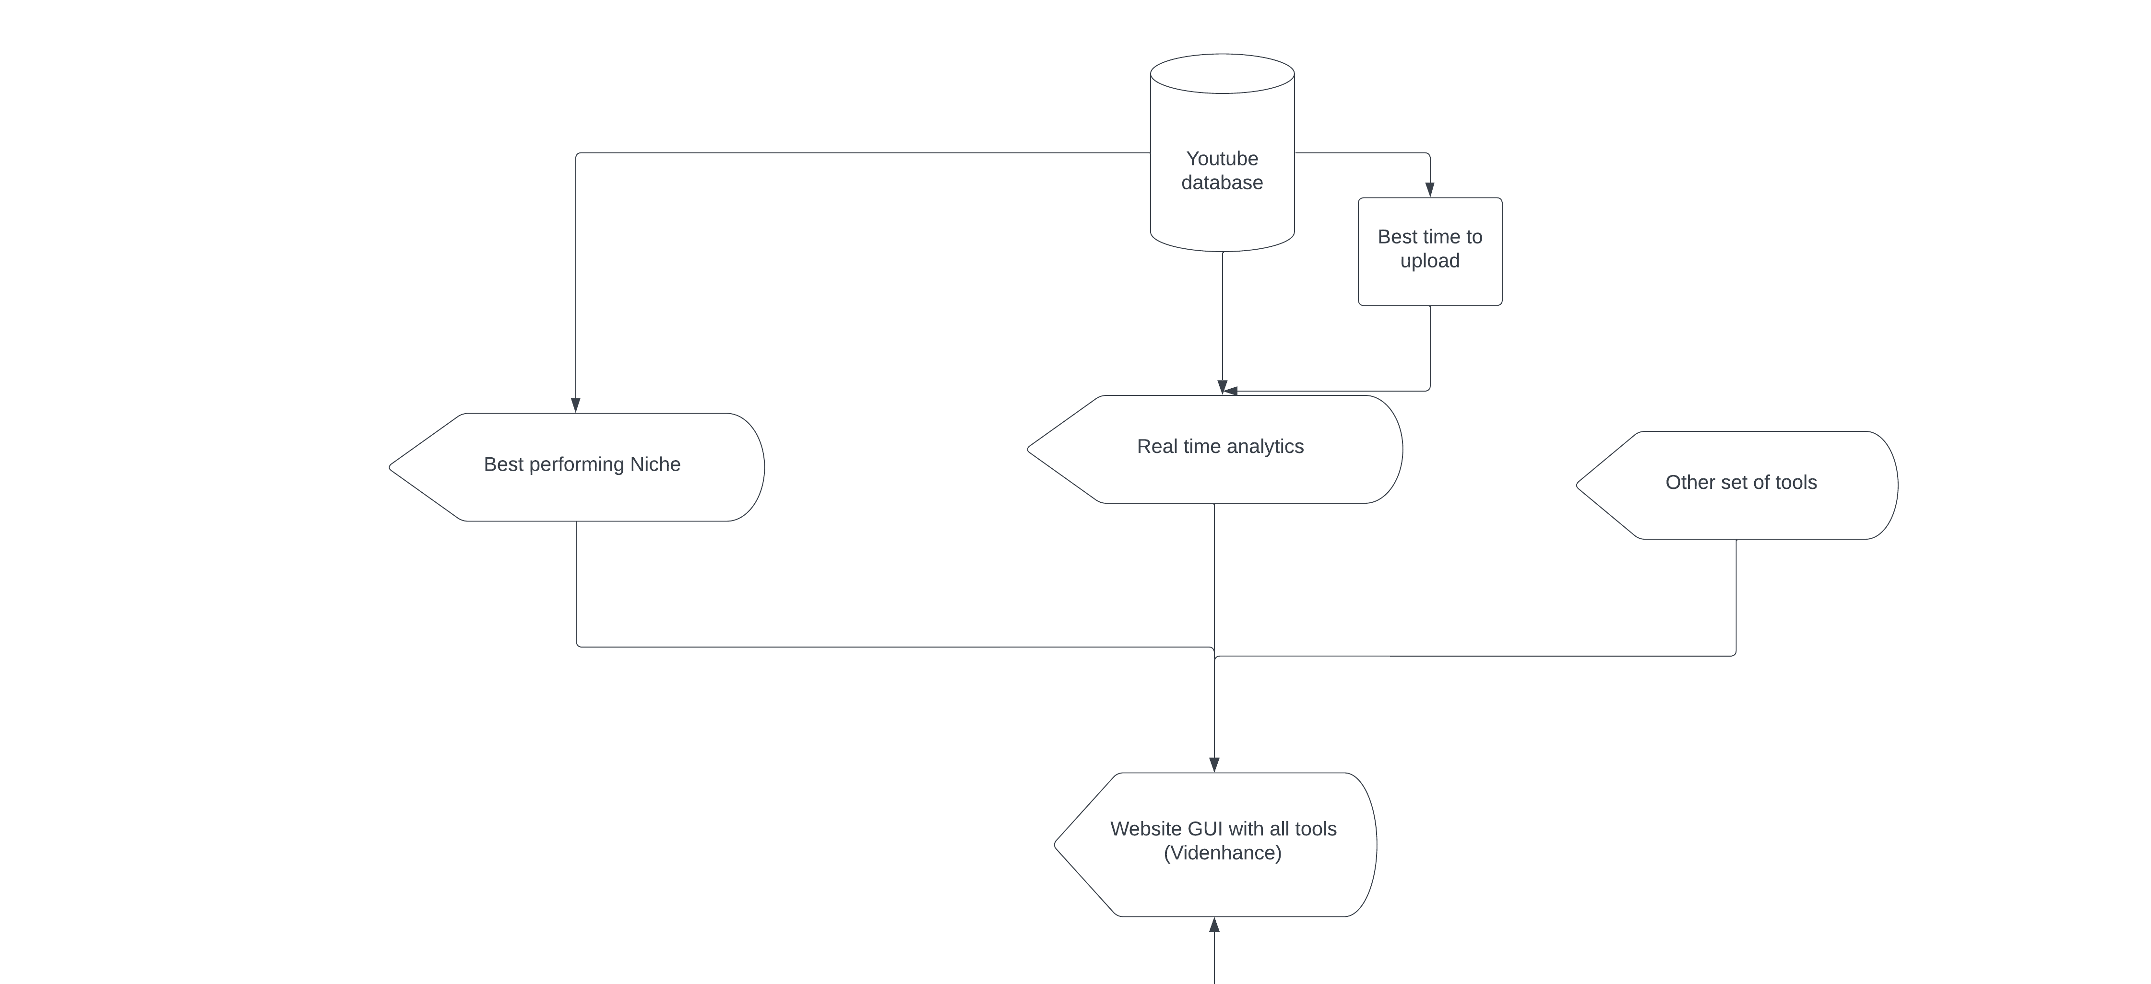

Fig 2.1

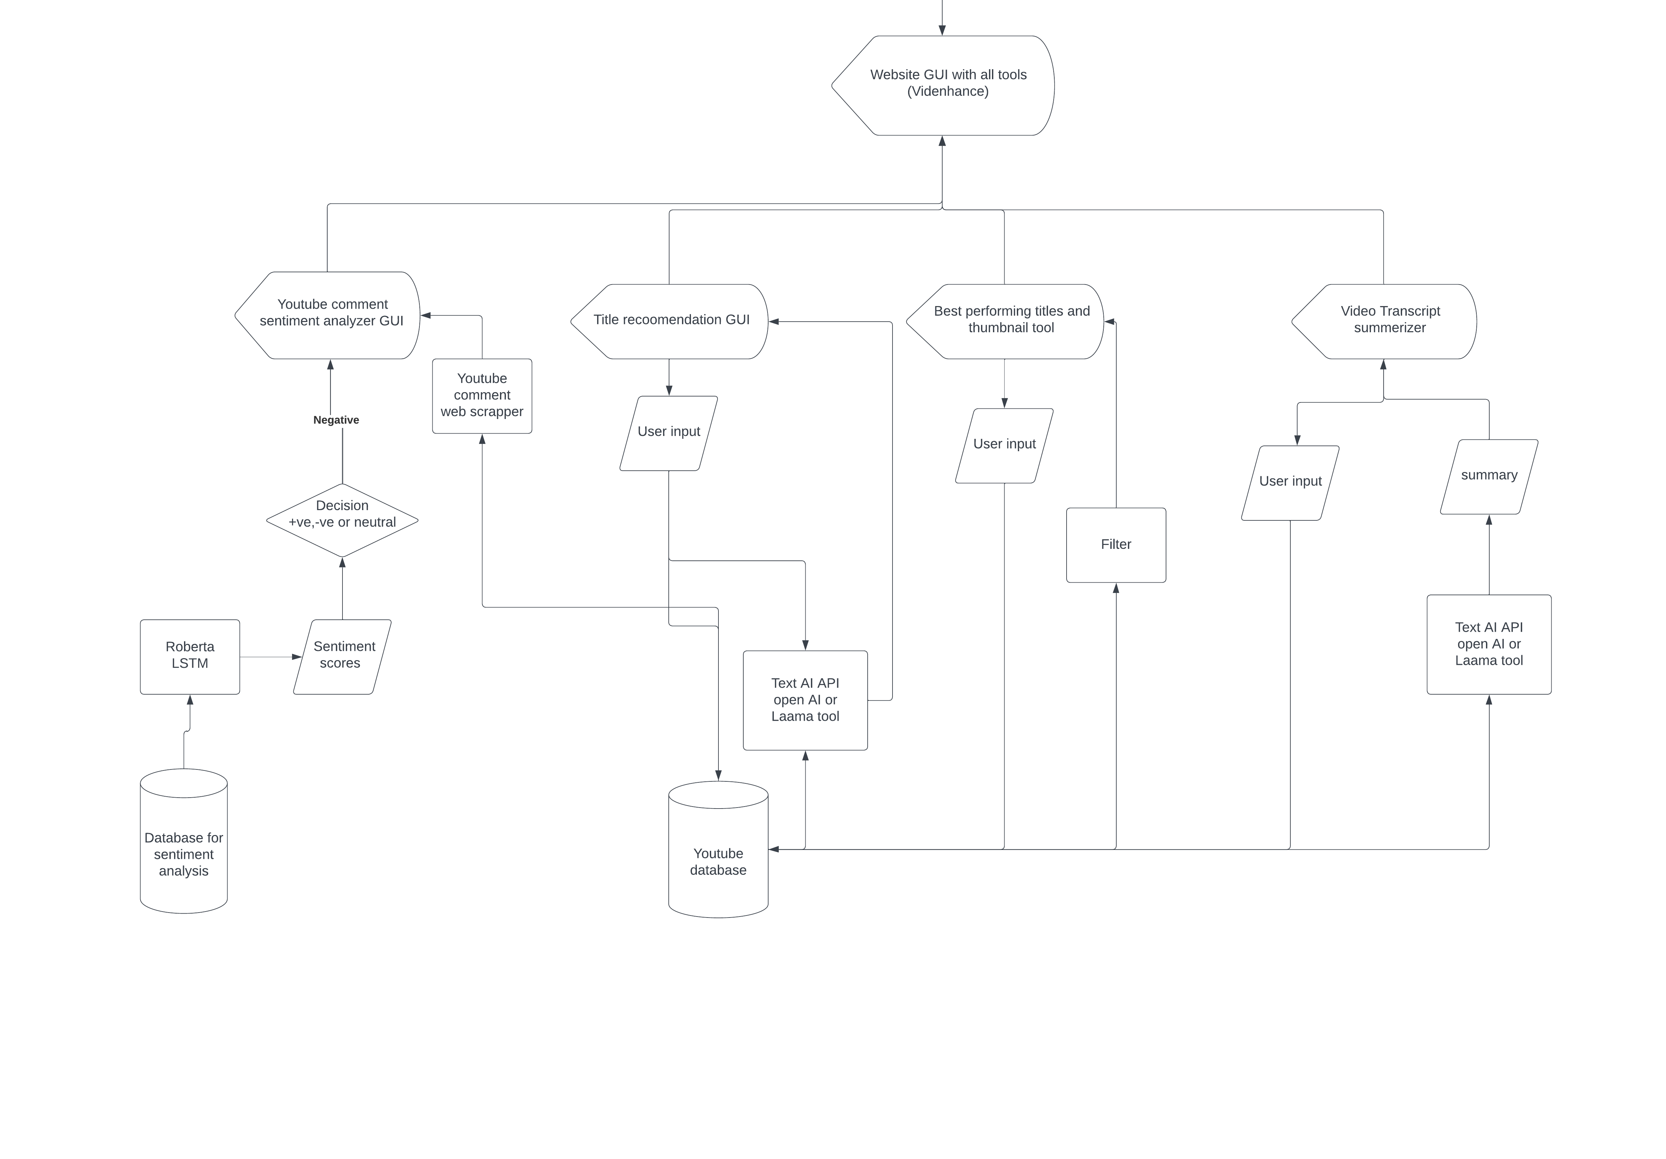

Fig 2.2

**10. Fully Developed Implementation’s Screenshot**

1. **Comment analyzer module**

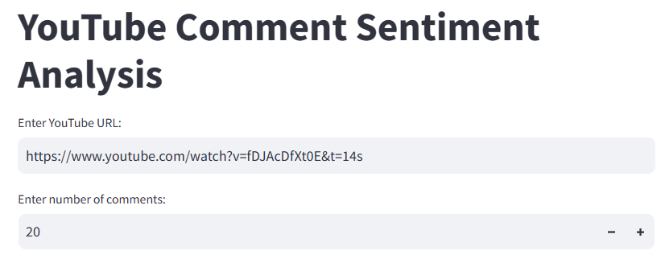

Fig 3.1

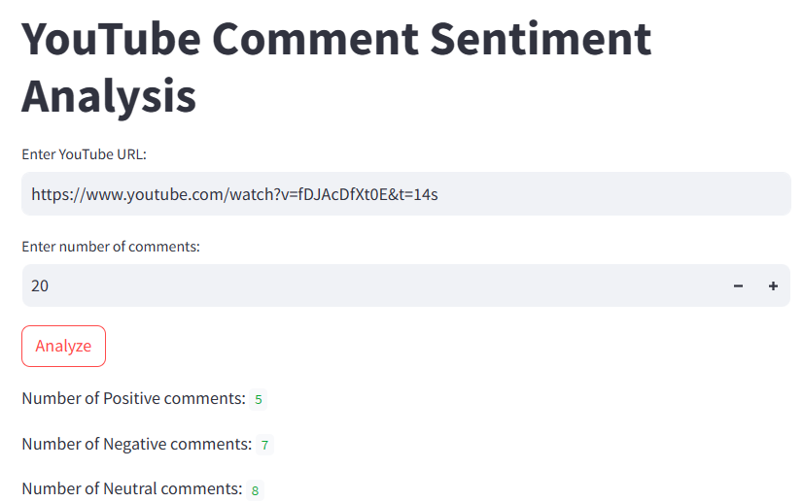

Fig 3.2

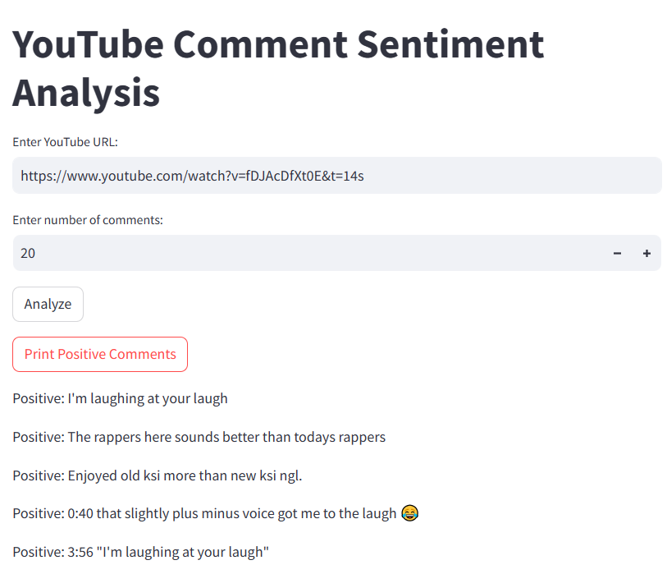

Fig 3.3

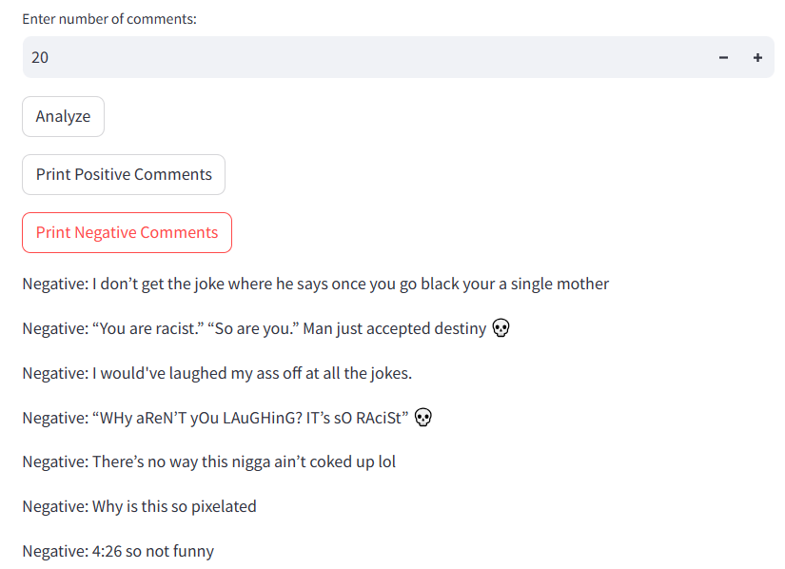

Fig 3.4

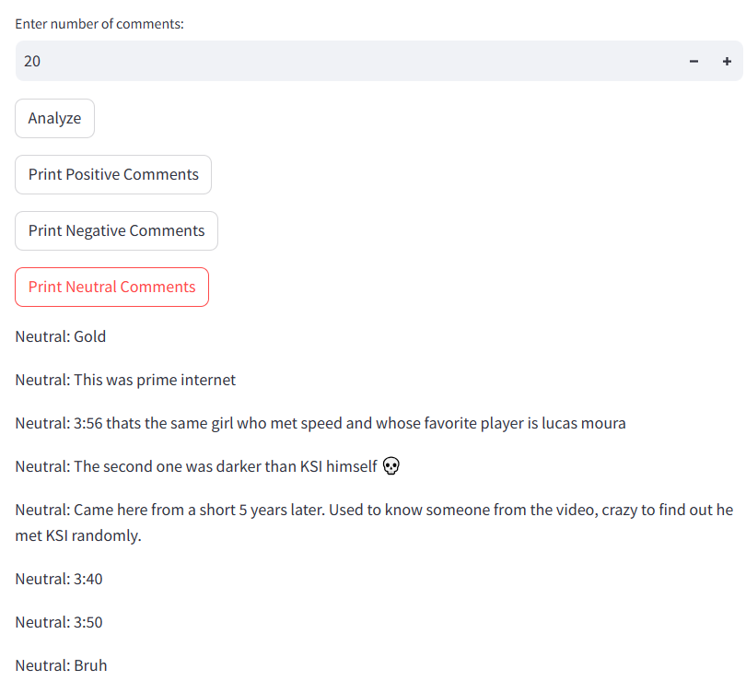

Fig 3.5

1. **Best Related Videos**

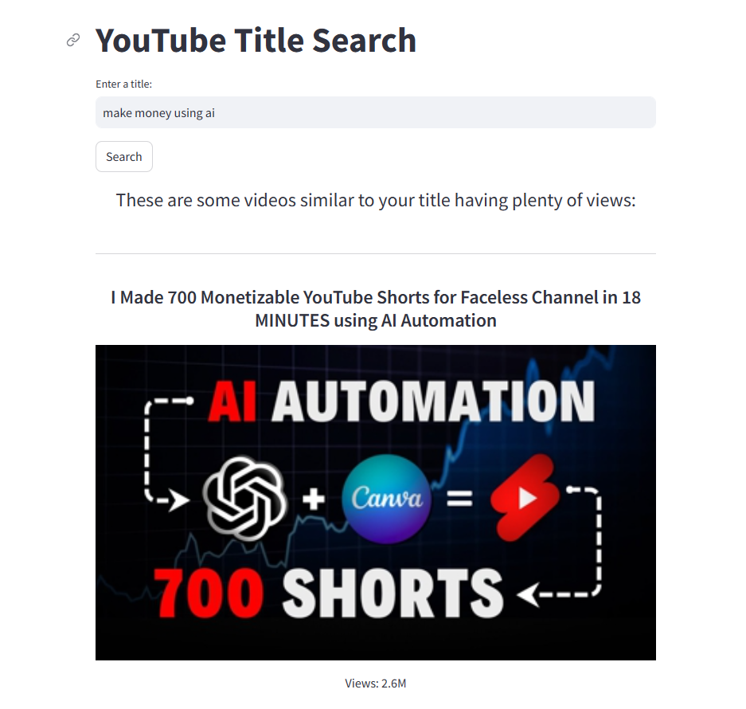

Fig 3.6



Fig 3.7

1. **Title recommendations**

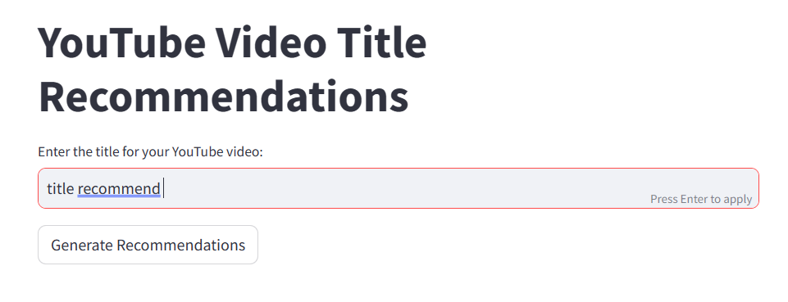

Fig 3.8

1. **Summary Generator**

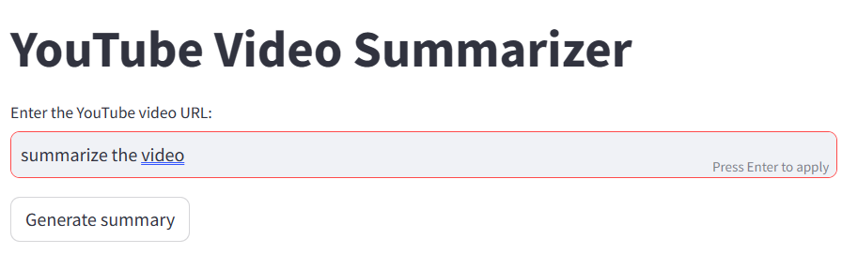

Fig 3.9

1. **Channel Id Finder**

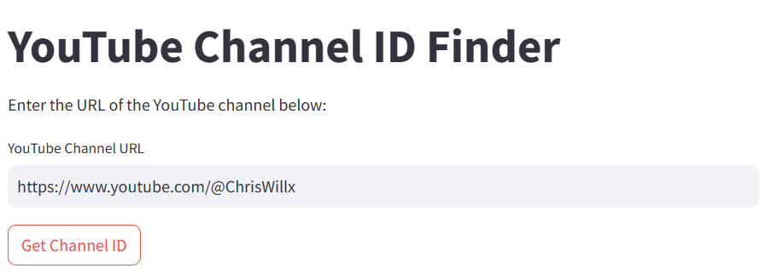

Fig 3.10

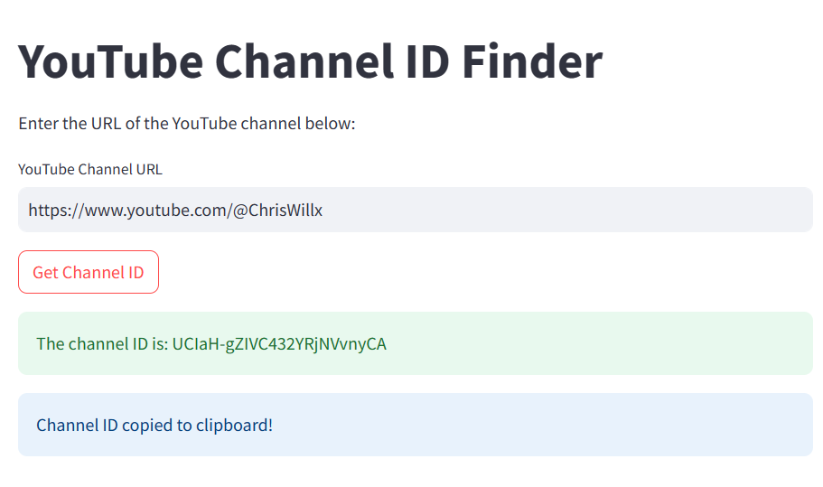

Fig 3.11

1. **Analytics Dashboard**

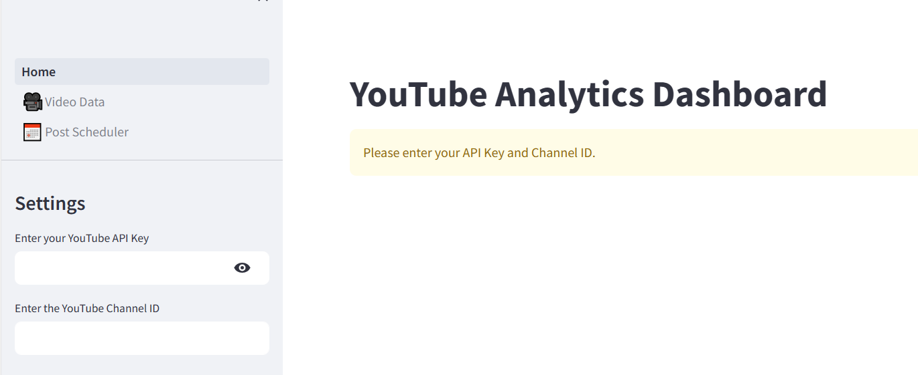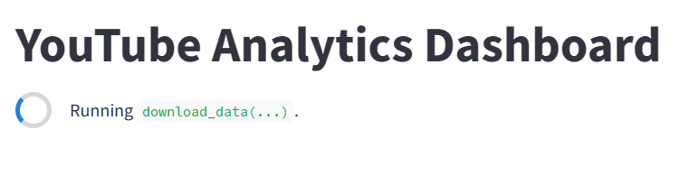

Fig 3.12



Fig 3.13



Fig 3.14

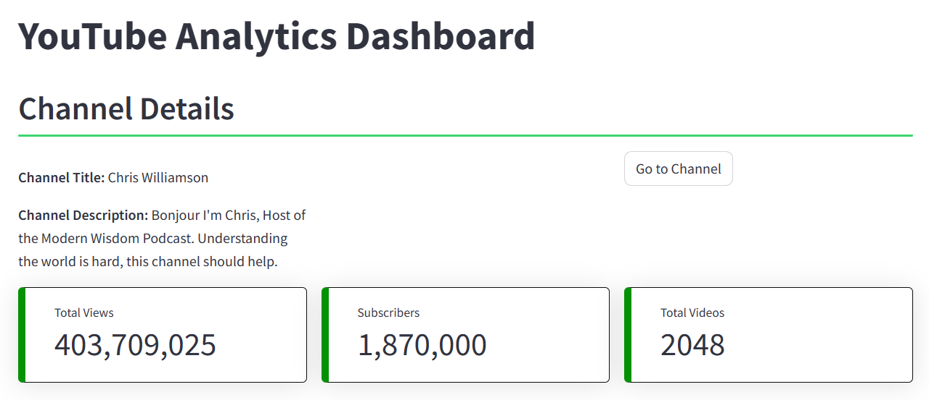

Fig 3.15

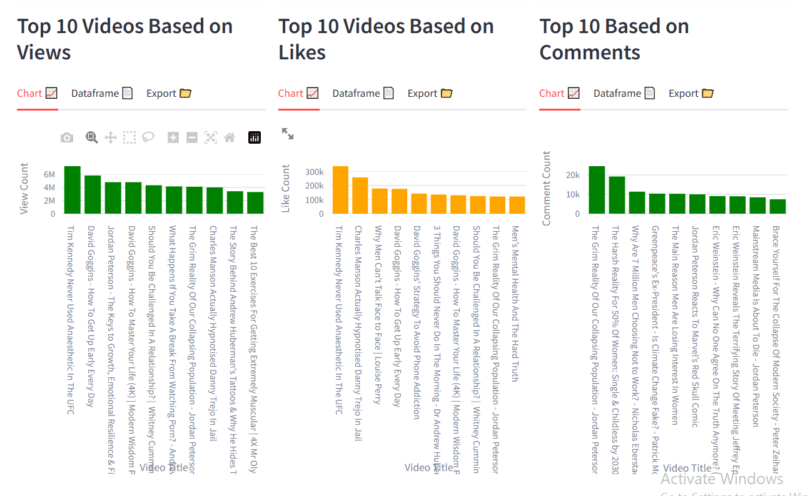

Fig 3.16



Table 2.1

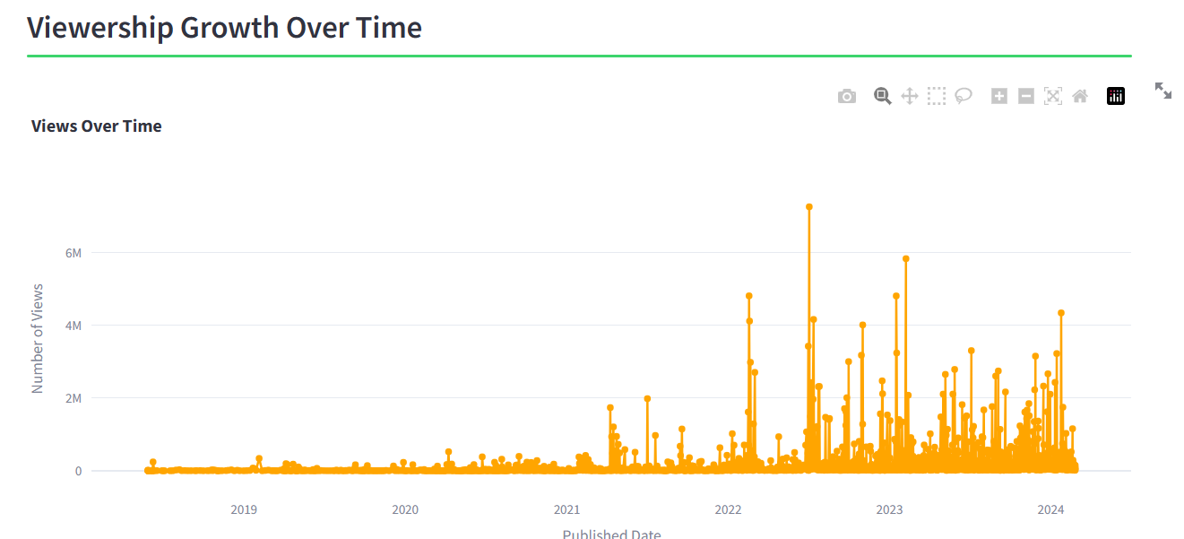

Fig 3.17

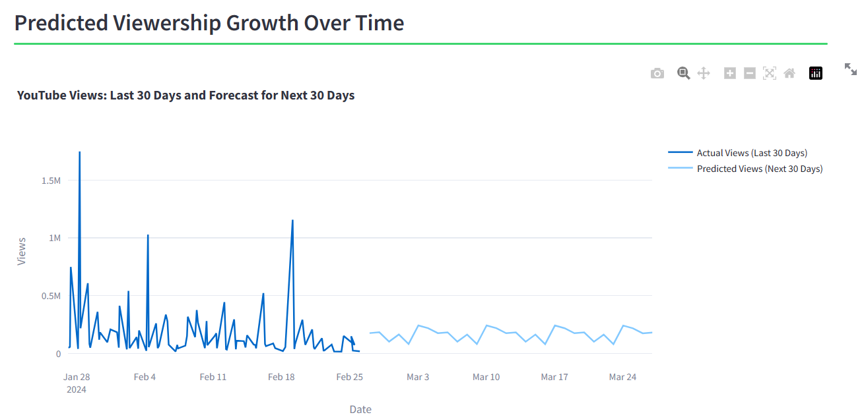

Fig 3.18

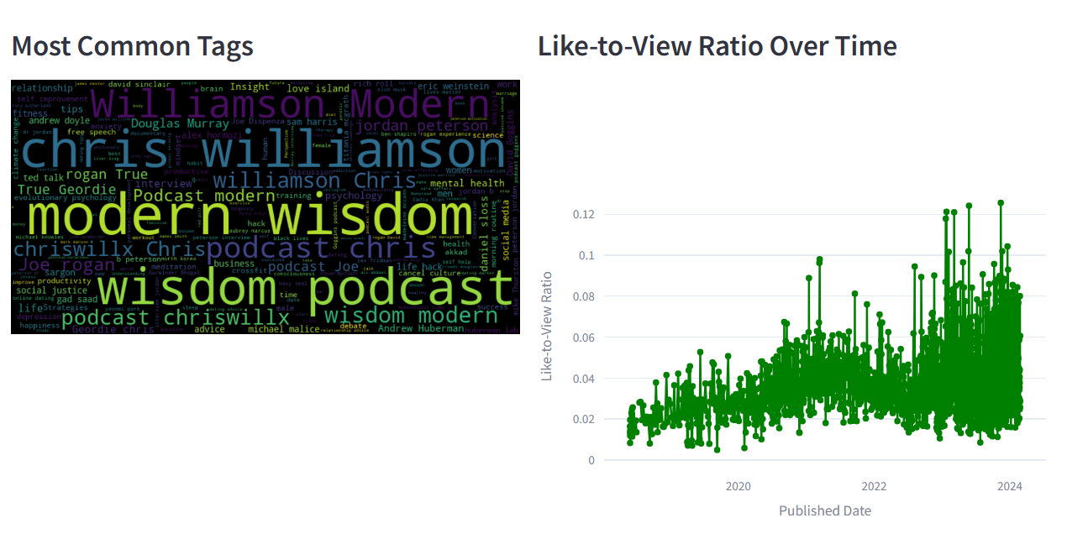

Fig 3.19

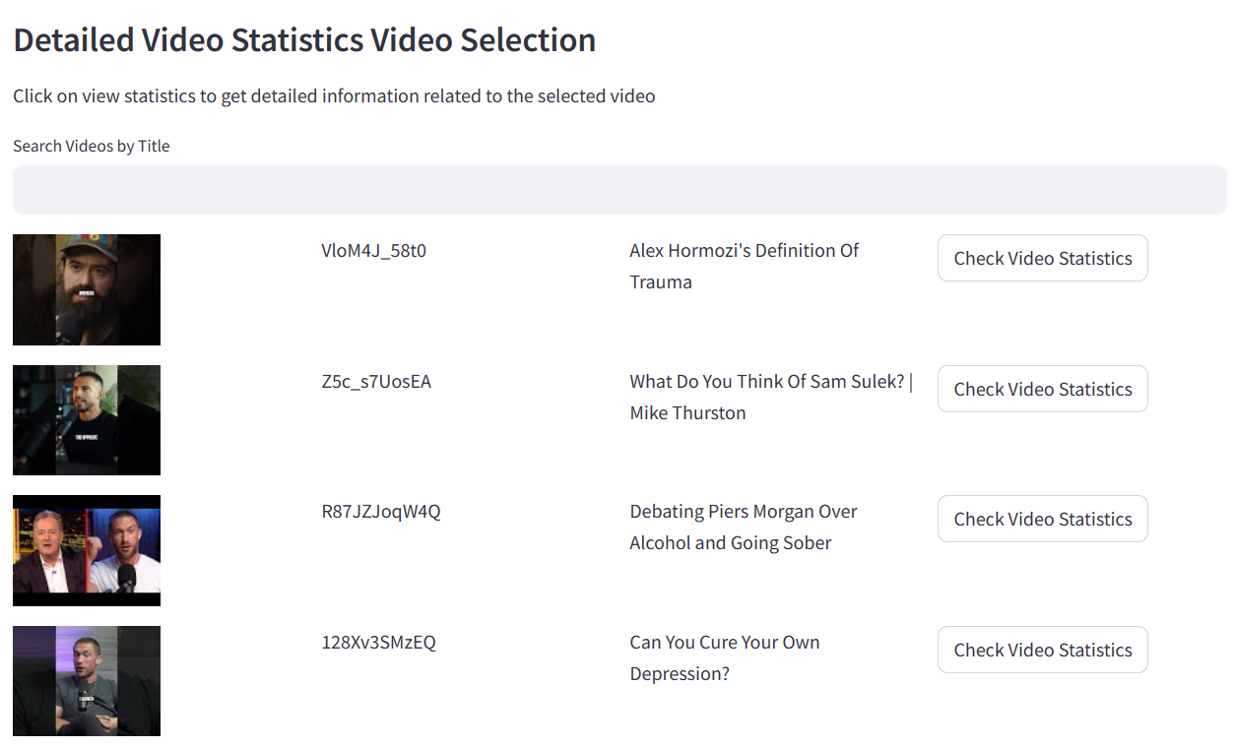

Fig 3.20

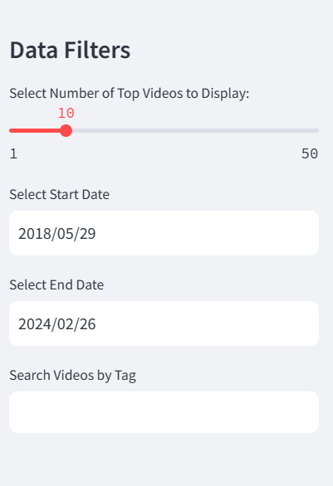

Fig 3.21

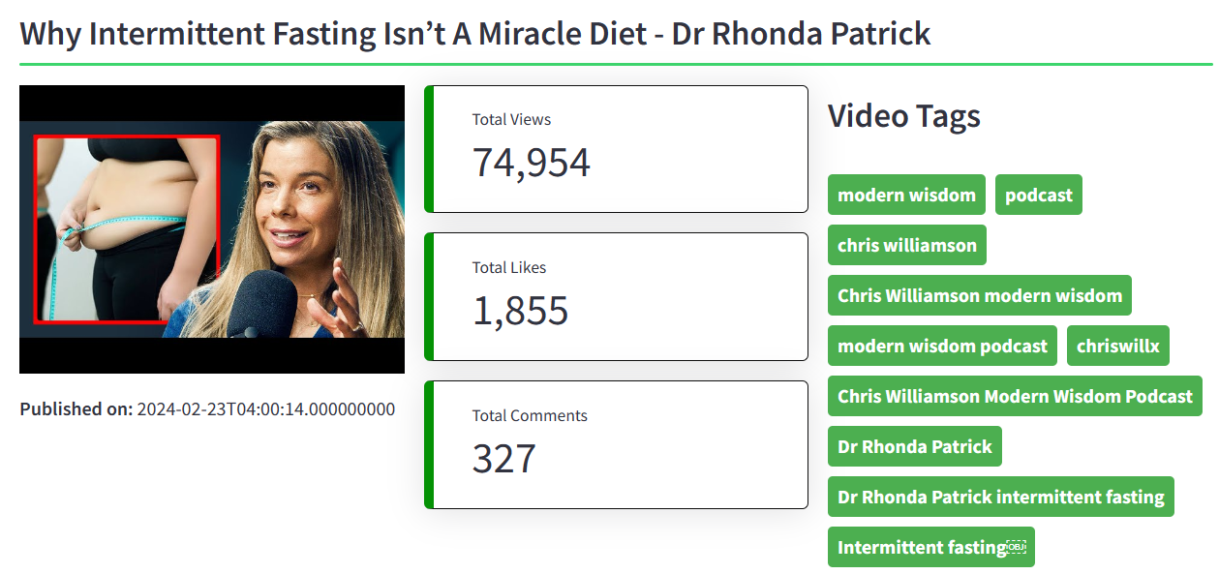

Fig 3.22

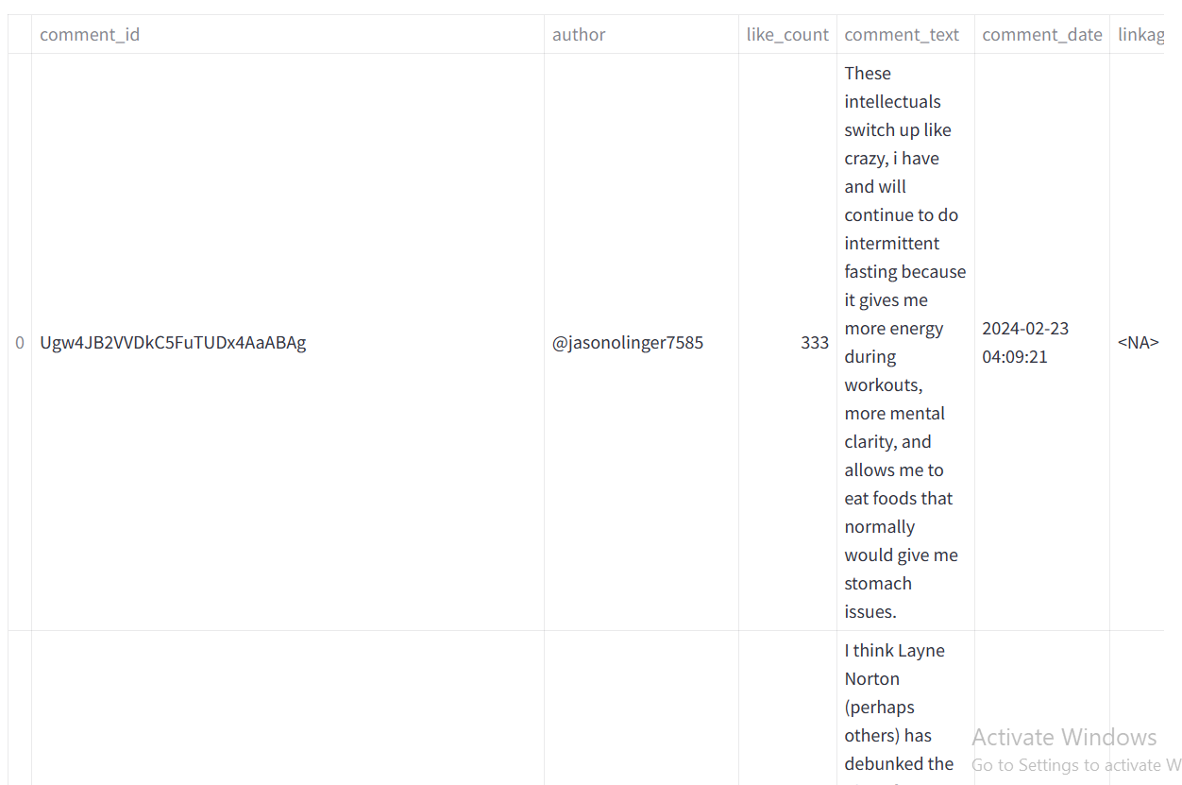

Fig 3.23

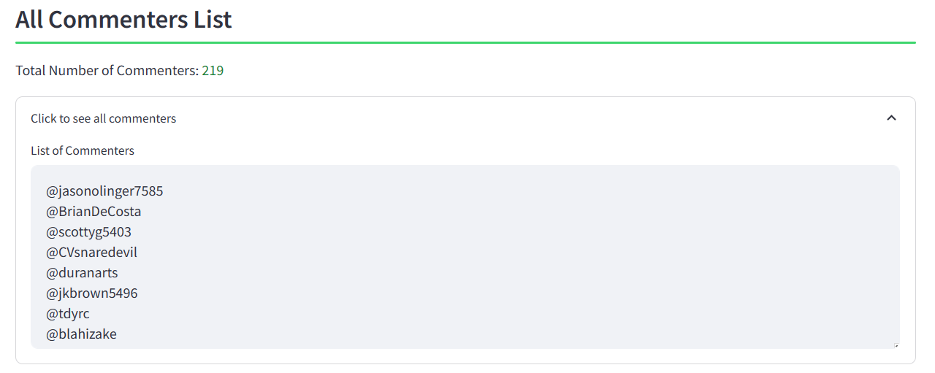

Fig 3.24

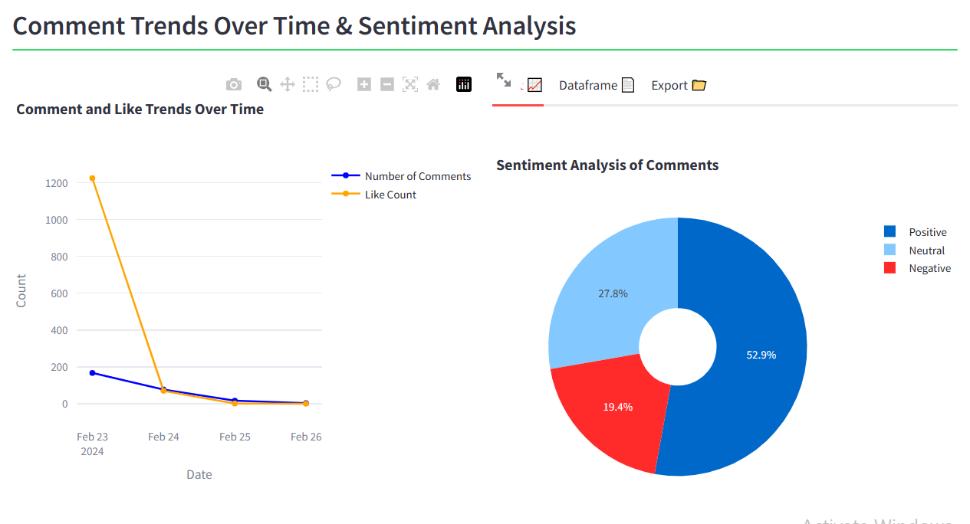

Fig 3.25



Table 2.2

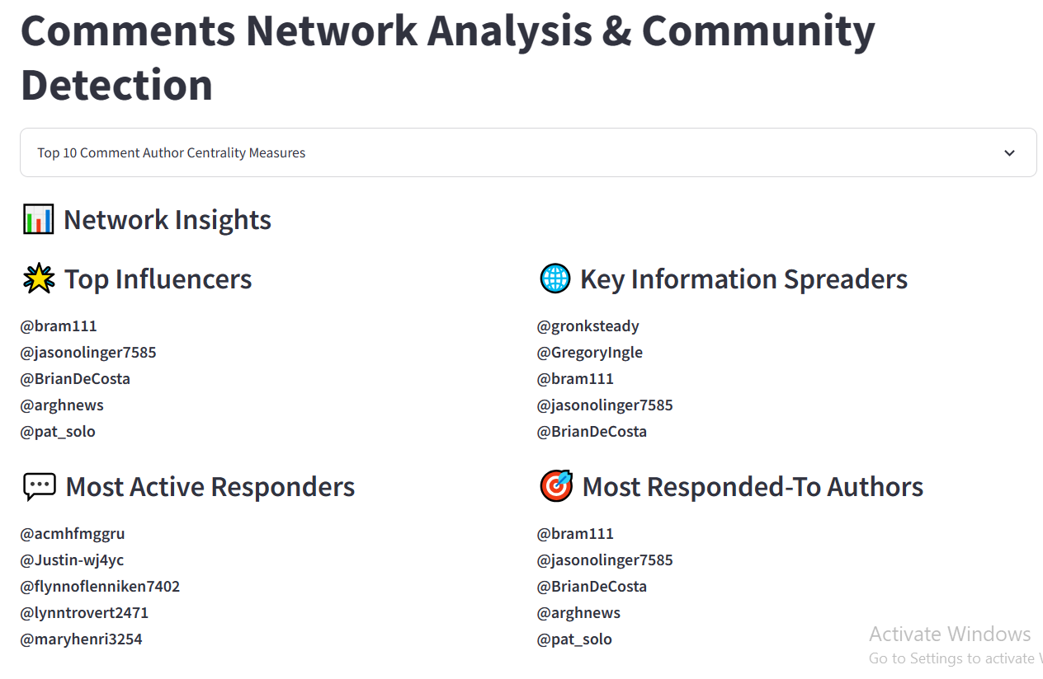

Fig 3.26

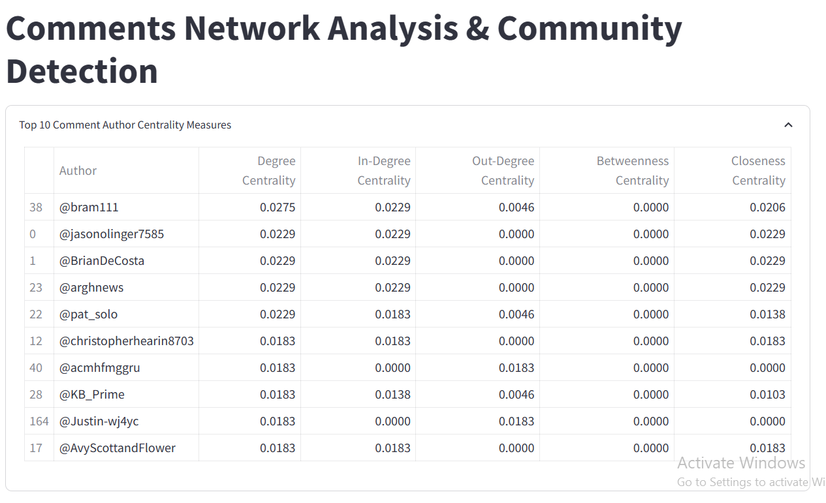

Fig 3.27

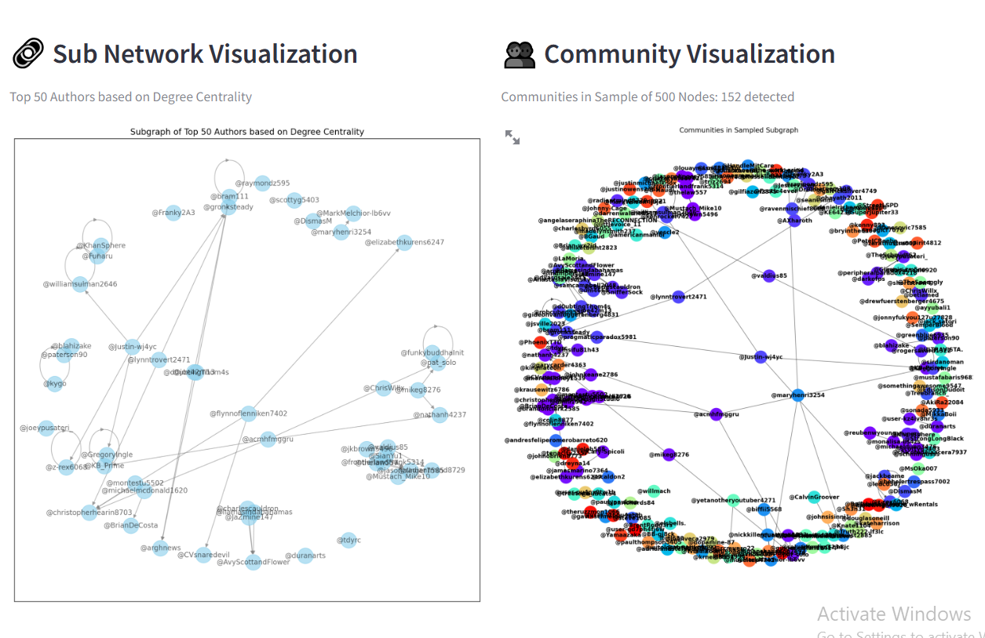

Fig 3.28

1. **Video Scheduler**

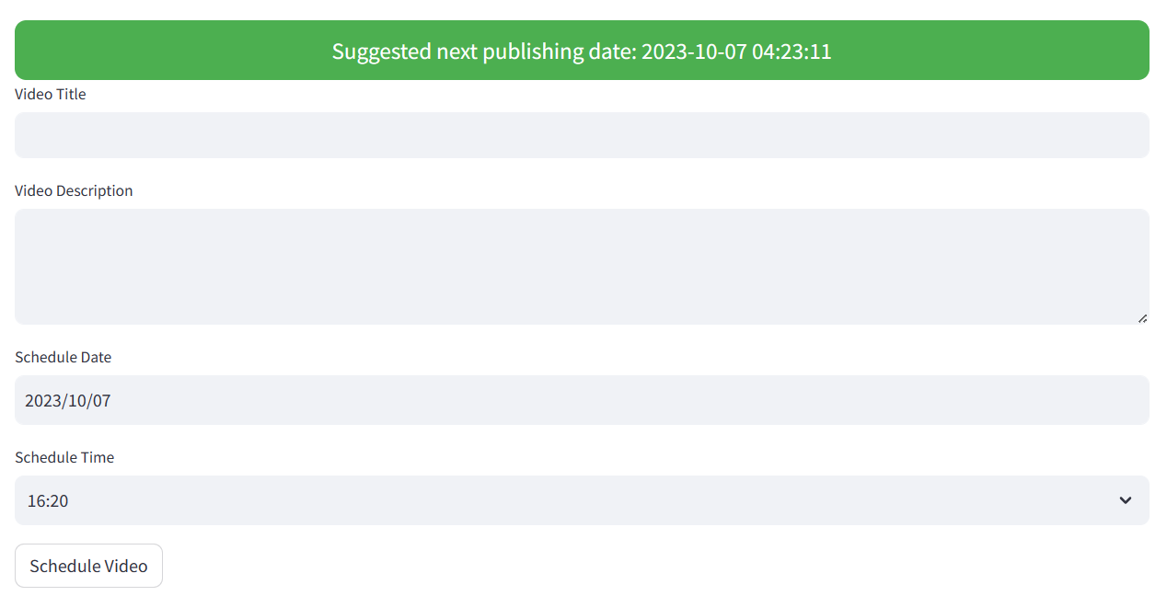

Fig 3.29

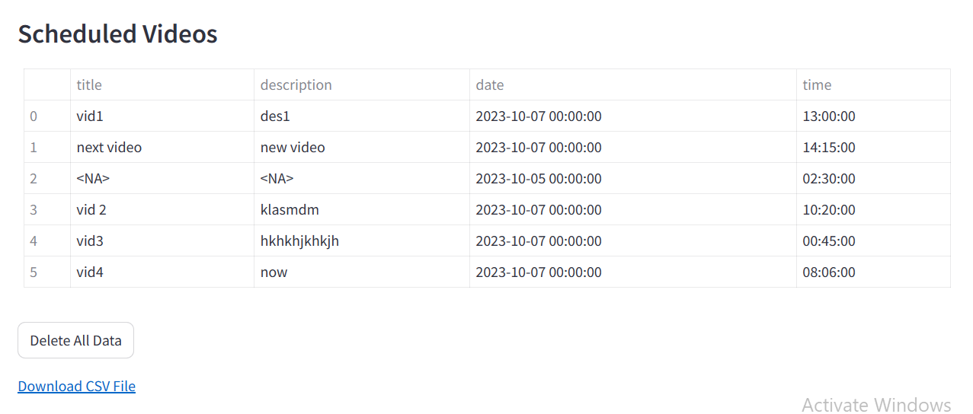

Fig 3.30

|  |  |  |  |
| --- | --- | --- | --- |
| title | description | date | time |
| vid1 | des1 | 10/7/2023 | 13:00:00 |
| next video | new video | 10/7/2023 | 14:15:00 |
|  |  | 10/5/2023 | 2:30:00 |
| vid 2 | klasmdm | 10/7/2023 | 10:20:00 |
| vid3 | hkhkhjkhkjh | 10/7/2023 | 0:45:00 |
| vid4 | now | 10/7/2023 | 8:06:00 |

Table 2.3

1. **Channel Monetization check**

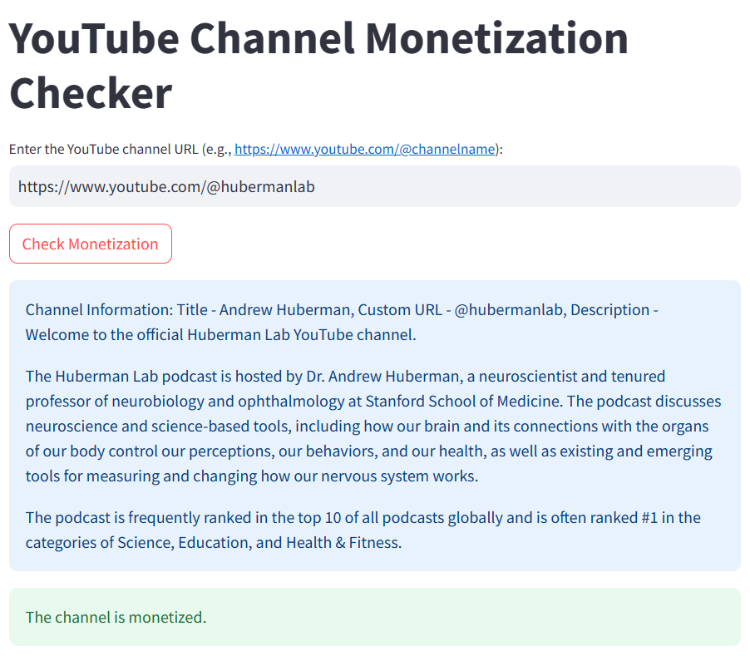

Fig 3.31

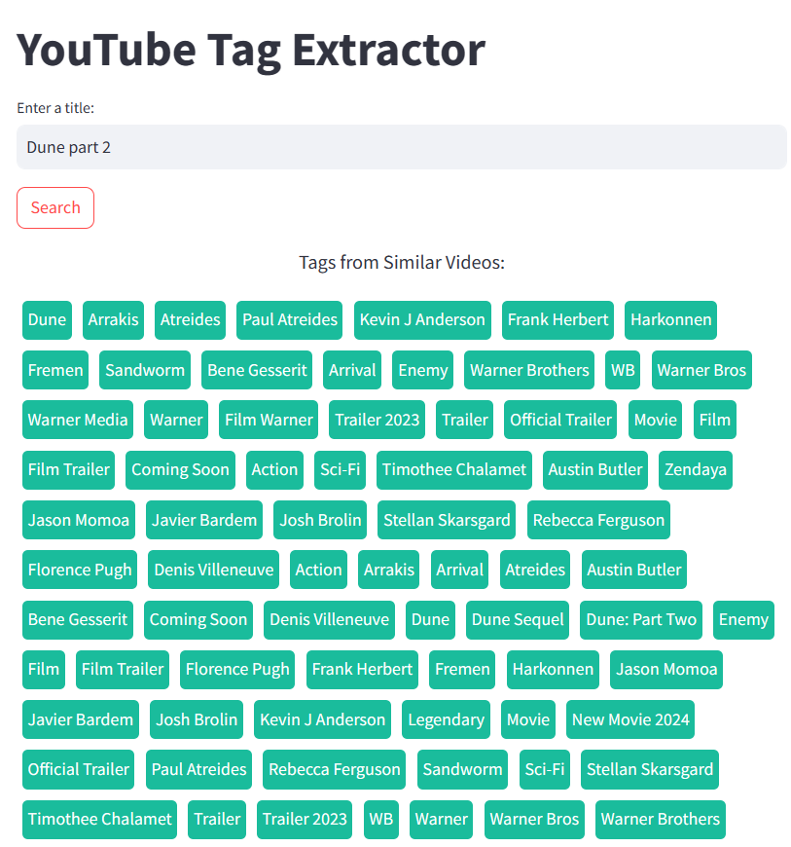

Fig 3.32

**11. Results**

The results of the Videnhance project are multifaceted and impactful, encompassing various aspects of content optimization, audience engagement, and channel growth on the YouTube platform.

1. **Enhanced Content Optimization:**

Videnhance provides content creators with powerful AI-driven tools, including the Title Recommender and Summary Generator, which optimize video titles and descriptions for maximum visibility and relevance. By leveraging advanced natural language processing algorithms, Videnhance enables creators to craft compelling titles and summaries that resonate with their target audience, ultimately enhancing content discoverability and click-through rates.

1. **Improved Audience Engagement:**

Through the Comment Analyzer Module, Videnhance empowers creators to gain valuable insights into audience sentiment, preferences, and engagement patterns. By analyzing comments in real-time, creators can identify trends, address concerns, and foster meaningful interactions with their audience, leading to increased viewer engagement, loyalty, and retention.

1. **Actionable Performance Insights:**

Videnhance offers comprehensive analytics and reporting functionalities, such as the Detailed Video Report, which provide creators with actionable insights into video performance metrics, including views, likes, comments, and audience demographics. By leveraging these insights, creators can make informed decisions regarding content strategy, audience targeting, and optimization techniques, leading to improved channel performance and growth.

1. **Streamlined Content Management:**

With features like the Video Scheduler and Channel ID Generator, Videnhance streamlines content management processes, allowing creators to schedule video uploads, track channel performance, and manage channel identification efficiently. By automating repetitive tasks and providing intuitive workflows, Videnhance enables creators to focus their time and resources on content creation and audience engagement, ultimately enhancing productivity and channel growth.

1. **Monetization Opportunities:**

The Channel Monetization Check functionality enables creators to assess their channel's eligibility for monetization and track revenue generation opportunities. By providing insights into monetization status and revenue potential (still to be done), Videnhance empowers creators to optimize their content strategy, explore revenue streams, and maximize earning potential on the YouTube platform.

The results of the Videnhance project culminate in a comprehensive suite of tools and functionalities that empower YouTube content creators to optimize their content, engage their audience effectively, and foster sustainable channel growth. By leveraging advanced AI technologies, intuitive user interfaces, and actionable insights, Videnhance equips creators with the resources they need to thrive in the competitive landscape of online content creation.

**12. Gantt Chart**

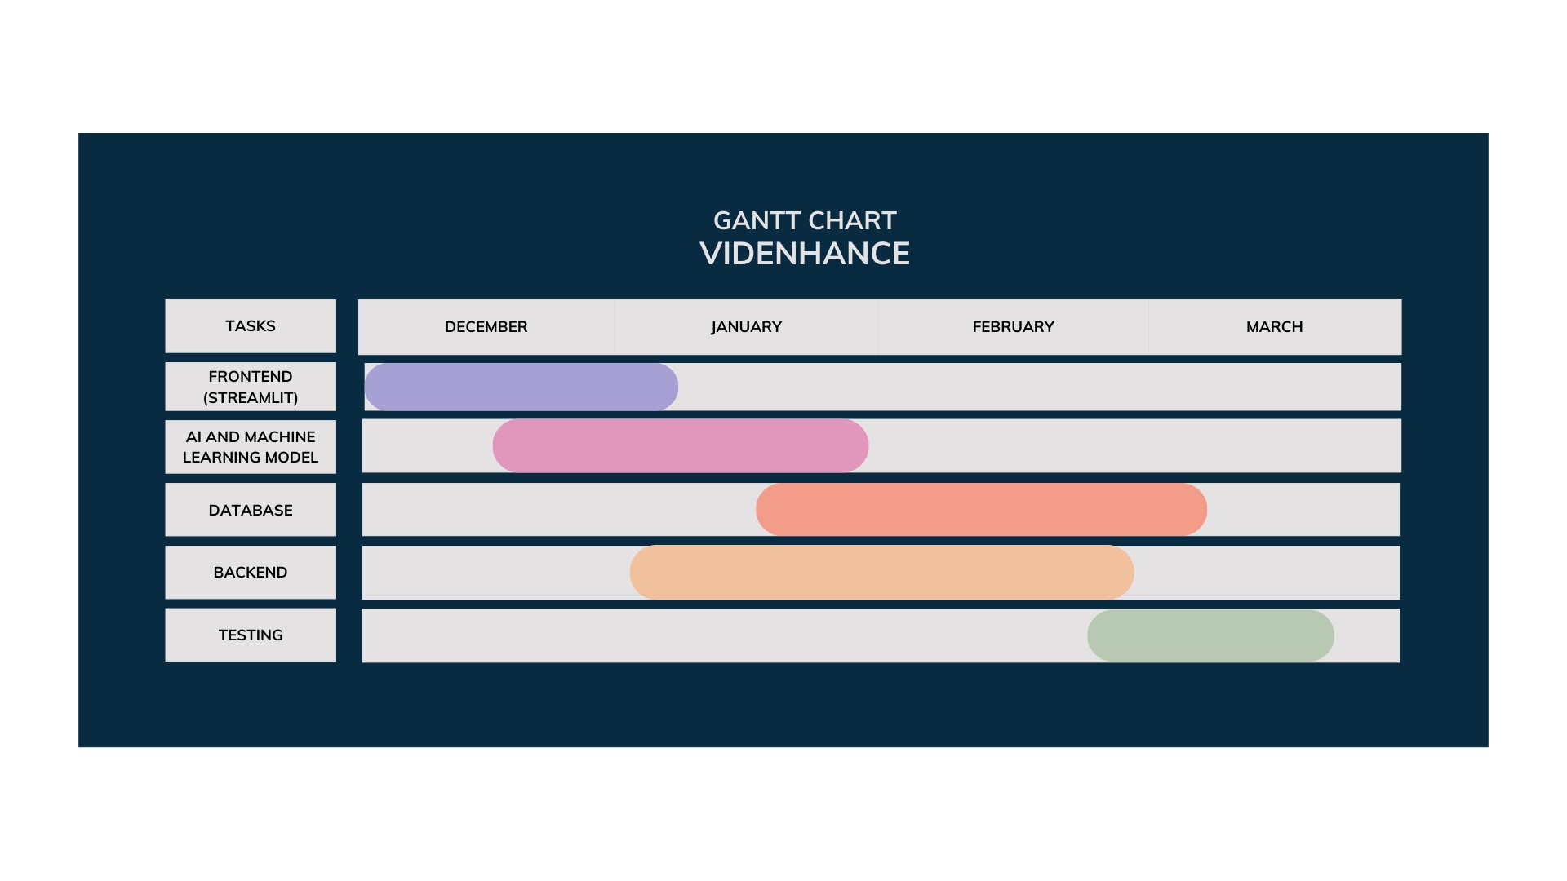

Fig 4.1

**13. Proposed Enhancements**

1. **Advanced Audience Segmentation:**

Implement advanced audience segmentation features within the Comment Analyzer Module to categorize and analyze audience feedback based on demographics, interests, and engagement levels. This enhancement would enable content creators to tailor their content and engagement strategies more effectively to specific audience segments, leading to higher levels of viewer satisfaction and engagement.

1. **Predictive Analytics:**

Introduce predictive analytics capabilities to forecast future video performance metrics, such as views, likes, and comments, based on historical data and audience behavior patterns. By providing creators with insights into potential performance trends, Videnhance can empower them to optimize content creation, promotion, and scheduling strategies for maximum impact and reach.

1. **Automated Content Recommendation:**

Develop an automated content recommendation engine that suggests relevant topics, keywords, and video concepts based on audience interests, trending topics, and competitive analysis. By leveraging machine learning algorithms and real-time data analysis, Videnhance can assist creators in identifying content gaps, capitalizing on emerging trends, and diversifying their content portfolio to attract and retain a broader audience.

1. **Interactive Analytics Dashboard:**

Enhance the analytics dashboard with interactive visualization tools and customizable reporting options, allowing creators to explore and analyze video performance data in-depth. By providing dynamic charts, graphs, and filters, Videnhance can enable creators to gain actionable insights, identify performance trends, and make data-driven decisions to optimize content strategy and channel growth.

1. **Integration with Additional Platforms:**

Expand Videnhance's capabilities by integrating with additional social media platforms and video-sharing platforms beyond YouTube. By supporting platforms such as Instagram, TikTok, and Facebook, Videnhance can provide creators with a centralized hub for content management, analytics, and optimization across multiple channels, enabling cross-platform promotion and audience engagement.

1. **Natural Language Understanding (NLU) Capabilities:**

Incorporate advanced natural language understanding (NLU) capabilities into the Comment Analyzer Module to analyze and interpret the semantic meaning and sentiment of audience comments more accurately. By leveraging state-of-the-art NLU techniques, Videnhance can provide creators with deeper insights into audience sentiment, preferences, and emotions, facilitating more personalized and empathetic engagement with viewers.

1. **Integration with E-commerce Platforms:**

Integrate Videnhance with e-commerce platforms to enable creators to monetize their content through product placements, affiliate marketing, and sponsored content partnerships. By seamlessly integrating e-commerce functionalities, Videnhance can unlock new revenue streams for creators and provide them with opportunities to monetize their influence and content effectively.

1. **AI-Powered Content Creation Assistance:**

Develop AI-powered content creation assistance tools that help creators generate video scripts, brainstorm video ideas, and optimize content formats based on audience preferences and trends. By leveraging AI-driven content generation techniques, Videnhance can assist creators in overcoming creative blocks, streamlining content production workflows, and delivering engaging and relevant content consistently.

These proposed enhancements aim to further elevate the capabilities and value proposition of Videnhance, empowering YouTube content creators with advanced tools and insights to thrive in the ever-evolving landscape of online content creation.

**14. Conclusion**

In conclusion, Videnhance represents a significant milestone in the realm of YouTube content optimization, audience engagement, and channel growth. Through its innovative AI-driven tools, comprehensive analytics capabilities, and user-friendly interface, Videnhance empowers content creators to unlock new levels of success and visibility on the YouTube platform.

Throughout the development and implementation of Videnhance, our team of university students has demonstrated a deep commitment to delivering a solution that addresses the diverse needs and challenges faced by content creators. By leveraging cutting-edge technologies such as AI and machine learning, we have created a platform that not only enhances content discoverability and audience engagement but also streamlines content management processes and unlocks new monetization opportunities.

The results achieved through Videnhance are tangible and impactful, with content creators benefiting from improved content optimization, enhanced audience insights, and actionable performance analytics. With features such as the Comment Analyzer, Title Recommender, and Detailed Video Report, Videnhance equips creators with the tools they need to make informed decisions, drive engagement, and foster sustainable channel growth.

Looking ahead, the proposed enhancements outlined for Videnhance promise to further elevate the platform's capabilities and extend its value proposition to new heights. By embracing advanced technologies, expanding integration possibilities, and enhancing user experiences, Videnhance is poised to remain at the forefront of innovation in the field of online content creation.

Videnhance is a testament to the power of collaboration, innovation, and dedication in driving positive change and empowering creators to realize their full potential on the YouTube platform. As we reflect on the journey of developing Videnhance, we are proud of the impact it has made and excited about the opportunities it will continue to unlock for content creators around the world.

**ANNEXURES**

# **REFERENCES**

[1] K. L. Tan, C. P. Lee, K. S. M. Anbananthen and K. M. Lim, "RoBERTa-LSTM: A Hybrid Model for Sentiment Analysis With Transformer and Recurrent Neural Network," in IEEE Access, vol. 10, pp. 21517-21525, 2022, doi: 10.1109/ACCESS.2022.3152828.

[2] K. Chauhan, H. Daharwal, N. Mukati, P. S. Kavimandan, "Text Summarizer Using NLP (Natural Language Processing)," in ICONIC RESEARCH AND ENGINEERING JOURNALS, vol. 6, issue 1, Jul. 2022, pp. 212-215, ISSN: 2456-8880.

[3] Choudhari, K., & Bhalla, V. K. (2015). Video Search Engine Optimization Using Keyword and Feature Analysis. Procedia Computer Science, 58, 691-697.

[4] Gupta, V., Diwan, A., Chadha, C., Gupta, D., & Gupta, D. (November 2022). Machine Learning enabled models for YouTube Ranking Mechanism and Views Prediction. DOI: 10.48550/arXiv.2211.11528. [License: CC BY 4.0]

[5] Fang, X., & Zhan, J. (2015). Sentiment analysis using product review data. Journal of Big Data, 2(5). DOI: 10.78850/arXiv.2211

[6] Joseph, S. R., Sedimo, K., Kaniwa, F., & Letsholo, K. (March 2016). Natural Language Processing: A product Review data.

[7] Moratanch, N., & Gopalan, C. (January 2017). A survey on extractive text summarization. In 2017 International Conference on Computer, Communication and Signal Processing (ICCCSP). DOI: 10.1109/ICCCSP.2017.7944061.

[8] Manjappa, R. S., & Kumar, A. (2020, June 11). Twitter Sentiment Analysis (No. ID: Not provided). Jain Deemed To Be University. 11 Pages. Posted: July 16, 2020. Retrieved from SSRN

[9] Widyassari, A. P., Rustad, S., Shidik, G. F., Noersasongko, E., Syukur, A., Affandy, A., & Setiadi, D. R. I. M. (Year). Review of automatic text summarization techniques & methods.1-15

[10]Pawar, S. U., Behare, O. S., Umap, S. D., Adhav, A. K., Pawar, B. B., Thakare, R. S., & Raghuwanshi, H. M. (Year). Review of text summarization techniques of documents.

[11]R, V., Ramesh, D., & M, H. (2023). Automatic text summarization–A systematic literature review. *World Journal of Advanced Engineering Technology and Sciences*, 08(02), 126–129.

[12]Yadav, S., Behra, A. K., Sahu, C. S., & Chandrakar, N. (2021). Summary and keyword extraction from YouTube video transcript. *Journal Title*, 03(06)

[13]Touvron, H., Martin, L., Stone, K., Albert, P., Almahairi, A., Babaei, Y., Bashlykov, N., Batra, S., Bhargava, P., Bhosale, S., Bikel, D., Blecher, L., Canton Ferrer, C., Chen, M., Cucurull, G., Esiobu, D., Fernandes, J., Fu, J., Fu, W., Fuller, B., Gao, C., Goswami, V., Goyal, N., Hartshorn, A., Hosseini, S., Hou, R., Inan, H., Kardas, M., Kerkez, V., Khabsa, M., Kloumann, I., Korenev, A., Koura, P. S., Lachaux, M. A., Lavril, T., Lee, J., Liskovich, D., Lu, Y., Mao, Y., Martinet, X., Mihaylov, T., Mishra, P., Molybog, I., Nie, Y., Poulton, A., Reizenstein, J., Rungta, R., Saladi, K., Schelten, A., Silva, R., Smith, E. M., Subramanian, R., Tan, X. E., Tang, B., Taylor, R., Williams, A., Xiang Kuan, J., Xu, P., Yan, Z., Zarov, I., Zhang, Y., Fan, A., Kambadur, M., Narang, S., Rodriguez, A., Stojnic, R., Edunov, S., & Scialom, T. (Year). Llama 2: Open foundation and fine-tuned chat models. *arXiv*, 2307.09288 [cs.CL].

[14]Roumeliotis, K. I., Tselikas, N. D., & Nasiopoulos, D. K. (2023). Llama 2: Early adopters' utilization of Meta's new open-source pretrained model. *Preprints*, 202307.2142(v1).

[15]Li, J., Tang, T., Zhao, W. X., & Wen, J. R. (2021). Pretrained language models for text generation: A survey. *arXiv*, 2105.10311 [cs.CL].

[16]Khan, M. L., & Malik, A. (2022). Research YouTube: Methods, tools, analytics. In M. Laeeq Khan & Aqdas Malik (Eds.), *The SAGE Handbook of Social Media Research Methods* (pp. XX-XX). Sage.

[17] Velicer, W. F., & Fava, J. L. (2003). Time series analysis. In *Handbook of Psychology*.

[18] Zhou Gui Zhou, "Research on Sentiment Analysis Model of Short Text Based on Deep Learning", *Scientific Programming*, vol. 2022, Article ID 2681533, 7 pages, 2022.

[19] Ruixue Duan, Zhuofan Huang, Yangsen Zhang, Xiulei Liu, Yue Dang, "Sentiment Classification Algorithm Based on the Cascade of BERT Model and Adaptive Sentiment Dictionary", *Wireless Communications and Mobile Computing*, vol. 2021, Article ID 8785413, 8 pages, 2021.

[20] Xingli Liu, Wei Zhao, Haiqun Ma, "Research on Domain-Specific Knowledge Graph Based on the RoBERTa-wwm-ext Pretraining Model", *Computational Intelligence and Neuroscience*, vol. 2022, Article ID 8656013, 11 pages, 2022. https://doi.org/10.1155/2022/8656013